**When an Unexpected Card Is Drawn**

Initial Edition

Copyright © 2013 Michael R. Wild

All rights reserved.

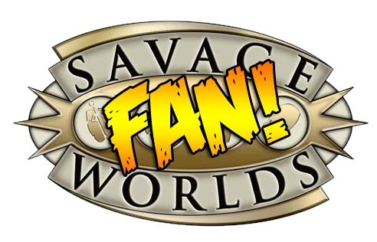

This game references the Savage Worlds game system, available from Pinnacle Entertainment Group at www.peginc.com. Savage Worlds and all associated logos and trademarks are copyrights of Pinnacle Entertainment Group. Used with permission. Pinnacle makes no representation or warranty as to the quality, viability, or suitability for purpose of this product.

This work is “fan” work and cannot be sold in anyway.

# Forward

I decided to try a new role-playing game system and that was harder than I expected. We old gamers have habits and memories that make it hard to change. It took me a while to decided on a new system. I tried some old game systems and finally I tried The *Savage Worlds*[1] and liked the system. *Agents of Oblivion* [2]material gave me a new chance to play a new system and also to play a new setting I liked back in the 1980s: Spies and horror. So I started a new *Agents of Oblivion* campaign set in 1974 based on my own version of the cold war. The campaign starts on the night that President Nixon resigns.

I also noted that most of the material is available for “one shots” and other short missions. My style is something much longer and larger plots. So I thought it would be a chance to write something longer for my campaign and get to understand *Savage Worlds* better. So this writing is a long multiple night adventure or multi-mission setting for *Agents of Oblivion*.

The AoO is not necessary to play. The “Director” could just replace it with other material.

**This document is meant for the Director’s eyes-only.**

# Introduction

This section describes the layout and structure of the multi-mission and then it describes the plot and structure of the missions and how they are tied together by central themes. It also explains how to use the material in the Director’s own campaign.

## The Pattern Used for Missions

The basic pattern used is the same as used for *Agent of Oblivion* one shot missions but it is expanded to a multi-mission format (a clip?). The plot is described and how the missions are connected to the plot. The missions contain the somewhat styled format of starting with name of a mission and a briefing for the mission. A text for the players is supplied in italics for the mission that may be read or paraphrased to the players by the Director. This is followed by a write-up on any resource items that are supplied to the agents and the players may then work with the Director to assign resources to their agents (*Agents of Oblivion*, here after called AoO, page 47) for the mission. The next section is to describe any information that the agents my try to find before starting the mission. The mission is then divided into numbered scenes that represent opportunities for the agents to take actions and participate, willingly or unwillingly, in combat. The scenes also have text in italics for the Director to read or paraphrase to the players and list of enemies and allies for combat and a usually a map. Often the Director can use a premade purchased map or draw one for the players to use; exact matching to the supplied map is unnecessary. A list of creatures, “Monsters,” and often specifications of the creatures are supplied or a reference to a “Monster” from Savage Worlds rules, here after called SW, may be found in section at the end of the scene. A scene may have an aftermath or the mission that follows its completion and addresses the results of the scene or mission (both positive and negative results) and this section will describe what happens to severally injured agents. For example, an injured agent hospitalized in a Western Europe country will likely mean a full recovery of an agent after a short while. In contrast, a critically injured agent in a Vietnamese jungle on a mission that will be denied by the Western powers in a 1970s setting is unlikely to recover. The epilogue will describe the completion of the multi-mission and the results of success and failures form the missions and a text epilogue to read or paraphrase to the players.

## The Plot

The adventure is a set of AoO multi-mission all connected by a tarot deck theme. Each mission is related to a tarot card and the agents will be introduced to the mission in some way. This may not be obvious to the agents. This card will be introduced as a dream or maybe as some other element that suggests a tarot deck card. Scarlet Gypsies, a group of misfits that use mystical powers to enhance their wealth and power, have discovered a power that changes events to their benefit. They have had tried to make the events look random but the power they have used always requires a payment and often links the events in a way that can be detected. The agency has detected the events and has sent the agents to explore and correct anything that is out of place. The agency does not know what is causing the events and is not heard anything more than whispers about a group known as the Scarlet Gypsies.

Each of the missions may give the agents information to understand that there is a central theme and they need to stop it. The Scarlet Gypsies have discovered a lost magical tarot deck that when drawn from grants power and wealth to the person or persons involved in drawing the card. It also causes dark forces to come into existence to grant the power and wealth. These forces will be spotted by a nemesis of the person or persons that drew this card, the agents in this case. The forces will reflect the tarot card drawn and this will be strongly hinted at to the agents in dreams, actions, and other obvious ways found in many of the scenes of the mission. Thus each mission will be called by the name of the associated tarot card.

# Mission: The Hanged Man

The tarot card is *the hanged man* that is often associated with change and unexpected events.

This mission is about a power that has been mixed into a software system to track hospital supplies. The software slowly drains the users of the software to mind-less zombie like workers. The agency has been asked to look into the strange behavior at the hospital. The link to the new software has not yet been made. The software company, H&P Systems, is a local group of former General Motors and IBM software developers who have made a go of it on their own and have produced a useable but rather uninteresting group of software screens and processes for hospital inventory control[3] that match the times, the mission is set in 1974 but can be easily moved to any period, and has been running without much difficulty (from a user’s perspective).

Harry Smith and Phil Jones, the “H” and “P” in the company’s name, wrote a workable if not exciting system for hospital and have continued to improve it as they sell it to other hospitals. Recently, the have ran out of cash and took on a partner, Mr. Love, to help fund their continued development. They were pleased that Mr. Love could get them some new hardware and even revised some of the underlying code that controlled the screen display and greatly increased the apparent speed of the software without increasing the processor power needed to run the screens. Harry and Phil are unaware that Mr. Love has installed arcane symbols into the screens—they appear for just a fraction of a second between screen changes—and some unique hardware, a vampire, added to the computers to use the symbols to drain psychic energy from the users. Mr. Love has also placed some defenses in the hardware to protect his investments including the vampire.

## The Briefing

The agents receive a short briefing in writing.

*The agency has become aware that something is wrong at St. Mark’s hospital in the USA mid-west. An agent, hurt in an unrelated case, was staying at St. Mark’s and while there was attacked by some form of zombie. The agent was well armed and was nervous after finding a tarot card, the handed man, in her hospital room. The tarot card was from an ancient deck of cards and the occult rating of gamma suggests that the deck may exist and be an occult alpha rating. Your mission is to determine the source of the attack, discover what forces are behind it, and of course to neutralize the source. As St. Mark is a private unaligned facility the agents are reminded to use discretion at all times and to protect the locals from the threat. The agency is concerned about the tarot card but as it is in the agency labs, the immediate threat is the zombies in St. Mark’s.*

*The agents are ordered to St. Mark’s to investigate and act against the occult threat to the area.*

*Knowledge of the threat and its resolution is restricted to agency personnel. Do not become involved with local officials.*

*It is unlikely to occur, should the tarot deck be discovered (alpha grade occult power), do not approach—contact the Agency.*

## The Mission Profile

The agents are in the open and should act with discretion and not end up arrested or in trouble with the local officials. The agents should be armed and prepared for an occult threat.

Threat: Undead incursion into an unaligned local facility.

Mission: Find and eliminate.

Parameters: Locals must be kept from knowledge of threat and its resolution.

Supplied equipment: All travel is supplied to St. Mark’s area as are rental cars, hotel rooms, and cost for normal expenses for travel. In addition agents may receive the following *perks:* cover identity, disguised gear, emergency contact, and one clip of modified rounds (Runic) (AoO page 59).

All other gear is available except air strike.

## Scene 01: The Hospital

The St. Mark Hospital has all the creepiness of a hospital that started in a time when antibiotics were new. The hospital is all plain brick and long corridors with heavy doors that keep sounds from being heard from a room. The white walls and high ceilings and heating pipes and registers for the hot water heat make it appear as a set for a horror films. The hospital staff is friendly and young and seems to try to make up a bit for the throwback look of their hospital. It is a small hospital and was founded long ago and has a grant and investments that make it a run for nearly free. It cannot pay much, thus the young staff, and the hospital has a low budget so it is not a trauma center nor does it do complex surgery. It is just an old fashioned friendly place in an aging facility with an underpaid staff that love the old place.

One new addition to the hospital is new software to track and stock supplies. The author’s campaign is set in the 70’s so the computer system in this setting would be huge IBM metal 3270 terminals (not lovingly called ‘boat anchors’ back then) with a “mini-computer” the size a large refrigerator called an IBM System/3 with lots of cables and tape drives and huge and loud printers all in a special closet/room with strong AC and a raised floor of computer room tile. Punch cards are used to record the use of hospital materials. Stacks of cards are then run to represent the use of supplies. If the campaign is set in the current time then it can be an “app” on various “shinny” hardware with the application connected to the “cloud” and there is no computer room. Barcodes are used then scanned by the hospital staff avoiding punchcards. H&P have installed their newest version of the their software in the hospital including the new DRaC, Data Retention and Calculation module. This is the vampire-based code. A terminal (either an old IBM style terminal or a touch screen in modern times) is available to access inventory levels. It is also the feeding location of the computer vampire.

*St. Mark’s Hospital is an older facility that may have once looked shinny and new, but now it is a bit sad looking. The old style brickwork, single pane windows, old metal fire escapes, and stone column entrance suggest a time before modern medicine. The hospital staff is young and friendly and seems to love the slow decay of the old facility. The walls white are clean and long hallways that are the focus of older hospital design have polished floors that reflect light so well they nearly glow. Flowers are everywhere, cut from a garden behind the hospital building. A short walk discovers that there are three floors and a basement. The basement contains X-ray, Lab, Special Services (morgue), and the boiler and other like facilities. The first floor contains Admittance, a small cafeteria, Emergency, and Clinic for basic health services. The second floor has patient rooms and nursing staff. A few rooms on the second floor have been converted into an inventory room and a shared office for the doctors and nurse to do paperwork. Also in the shared room is a lone terminal on a small table—this is part of the inventory management system. The third floor contains a small surgery area, administration and contains all the normal office to run a medical facility: Records, Accounting, Mailroom, and so on. A large room with large windows looking at the garden has a theater at the center with chairs in circle around it going up. It looks like a throwback to the 1880s when an operation was done in a theater.*

*You notice that the doctors and nurses are young and many are in training. St. Mark’s Hospital is based on a grant that let it help anyone and keeps the doors open, but it appears that salaries are low so St. Mark’s is now a training hospital. It also does not have a maternity ward or a full trauma center; it is a basic medicine and surgery hospital. The staff is proud that they serve those who cannot pay for good basic medical care.*

The agents may explore the hospital and learn these additional facts based on their talents to get more information.

### Missing Persons

A few patients have recently walked away. This happens at all hospitals and it is assumed that they left on their own accord. All the patients had no family and admissions had no way to follow-up on them. The pattern has not yet been noticed. An agent that got access to the admission records would notice it is a recent pattern. These are victims of the computer vampire.

### Persons and department breakdown

The agents will likely explore the hospital and look for information and persons to interview and suspect. The sections are divided into departments with a text to read to the players or to paraphrase. Some additional notes are also supplied.

**Finances:** *The hospital is indeed funded by a gift and by carefully investing the funds the hospital has turned a small profit that it has used to purchase updated medical equipment and an inventory control system to reduce costs*.

Mr. Tom Allen is the accountant that manages the investments and he is a typical accountant with glasses and no time to waste on trivial matters. The agents can break in or convince Mr. Allen to explain the investments. There is nothing in the investments other than blue-chip stocks and normal bonds. On the expense side the only odd item is the H&P system purchase. The price is very low for the hardware/software. There is none of the usual request for advertising and using the hospital name to help defray a low cost. Mr. Allen has seen a reduction in costs in inventory as they only carry now a three day supply of many items and they can replenish with less waste now. Mr. Allen is very pleased with H&P software and smiles when he talks about return on investment (ROI) on the purchase. He will point out that the DRaC software is actually not run but connected to (either by modem in a setting of the 1970s-95s or by the web or the cloud).

**Facilities:** *The hospital was designed in a time before antibiotics and modern surgery. The hot water heat boilers are huge and very energy inefficient but well maintained and running well. The building is clean and polished to an extreme. The kitchen is modern and covered with shinny aluminum, a gift from a happy patient who paid for the remodel. The plumbing is visible but well maintained with very old-fashioned fixtures that are lovely polished and kept in perfect working order. Lighting is a bit dark in places but random additions of various style lighting fixtures has brightened up the halls and rooms. There is no real order to the fixtures and vary by floor and area.*

Mr. Harry Curtis, called “Mr. Curtis” by all, is an African-American who is old school towards janitor work. He takes nothing from anyone and believes he “owns” the hospital and everyone is an interloper to his clean halls. He works weekends and long hours to keep the facilities running. Mr. “Buz” Jones is Mr. Curtis’s assistant and he does what the boss says and when Mr. Curtis retires in a few years, “Buz” will take over. “Buz” or “Mr. Curtis” is always working on something. The only complaint is trying to locate them when something goes wrong. If asked anything they will automatically ignore the question and tell the asker to head to the office for answers, “they just work here.” The agents will have to convince the janitors they should confide in the agents. “Some weird is happening on second floor—unnatural,” says “Buz” in whispers when talking about it. Mr. Curtis supports this by simply stating, “We clean the area around the offices on the second floor during daylight,” Mr. Curtis says with a smile. If pressed they say they have heard footsteps and seen folks working late on the computers there—when they check back the room is empty and things are moved around.

Ms. Emily Heights is the engineer and runs the boilers and does basic electric repairs. Emily is a young and good looking 20 something that found her niche at the hospital: Maintenance. Emily decided that college was not for her and looked for work and found a job at the hospital. She is smart and a quick study, but cannot finish much and is always disorganized. Emily appears at work as a tomboy in overalls and grease on her face and plays a man, but actually she is curvy and attractive gal that has had many boy friends. Emily has improved the lighting with various fixtures and has re-run plumbing here and there but none of the changes are according to any plan.

Ms. Heights will not be able to stay on topic if questioned and will not be interested in much except pipes and electrical panels. Agents will have to be very persuasive to get any information from her. If asked about anything strange she will mention the morgue as strangely cold (she is afraid of the dead) and scary. If asked about the second floor she will mention that area has had problems with static and she has tried to put in some extra grounds in the area by the office and other computer equipment. Her work hours do not put her on the floors at night.

Lab, X-Ray, Special Services (morgue): *The lab, x-ray, and morgue are all in the basement and by definition a bit spooky in an older building like St. Mark’s. The lab techs and x-ray techs are all very young but skilled and seems to like the spookiness and stillness of the basement. Any requests about paranormal will get blank looks or made up stories that can be quickly traced back to popular writings (Poe, H.P. Lovecraft, and so on). Everyone says the morgue is spooky. It is a morgue and it is chilled and it has the required slabs, hoses, and box doors to storage for the dead. It is spooky as are all morgues.*

Mrs. Mary Smith runs the lab and she is 30 something and runs the lab like a drill sergeant. The lab techs don’t mind as Mary is kind to them, but everything must be done right and clean for her to be happy. She has no time for agents and has no information for them.

Dr. Eugene Howe[4] is an older grayed haired man wearing old-style metal-rimmed specs and runs the x-ray and morgue and is a character at the hospital. He makes a point of wearing other people’s badges and pretending to be them when someone is looking for him. He is never in at his small office and often is helping with the x-ray staff or in the morgue helping with a “short-stay” guest, what he calls the corpses. Everyone knows that Dr. Howe is unstable but he works for free, having earned a large fortune in the stock market on a lucky guess, and is extraordinarily competent at taking x-rays and reading x-rays. He is also skilled at pathology and covers any needs there for the small hospital.

It was his experiences in pathology that made him so unstable. He performed an autopsy on an alien and has been unstable since. Some how the exposure to the fluids of the alien greatly increased his intelligence but made him fearful of being “found” and “taken” by the aliens. Dr. Howe suspects that the “aliens” are involved in the strange static problems on the second floor. He has been much more careful about not being him now. He never wears his nametag and has order duplicates of other folks that work at the hospital. He is often “Peggy Smith” who is on maternity leave and an x-ray tech. Mrs. Smith will not give him up and sticks to, “he is not in” when asked. She does not want him in the lab and so agrees to not “expose” him if he stays away from the lab. The agents will have considerable trouble finding him, but may play on his paranoia to get information. He is certain that the aliens are on the second floor and that metal foil placed on the head will NOT protect anyone. He is very fearful of the new computer system and wonders if “DRaC actually means Direct Alien Communication.” It should be obvious that Dr. Howe was involved in something that effected him the past. He is harmless.

**Admissions:** *Admissions is a set of desks placed in a hallway with a small waiting area. A Mrs. Audrey Shultz is in charge. She is young and friendly, but seems to turn many ill people away as the hospital has limited space and handles more basic care. Broken arms and other short items are quickly handled, but many ill folks are turned away and with a smile sent to another hospital, “sorry no room at this time” or “specialized care is needed and these folks are who you should see.” There is compassion but the resources are few at the hospital.*

As this is a privately funded hospital and only serves basic needs, it has a complex admission process. Mrs. Audrey Shultz is a young bubbly gal of 30 something that handles admissions and a group of hourly clerks that help with admissions. There are not many forms and Mrs. Shultz easily sends patients to other hospitals, “No dear you will have to go to the hospital downtown.” Mrs. Shultz is unaware of anything odd happening at the hospital other than needing more rooms.

**Care and Nursing:** *Nursing care appears better than older hospitals and very modern in style. It is also clear that the head nurse, Nurse Hawthorn, is old school and is proud of the level of care supplied at the hospital.*

The main nurse is a retired military nurse who matches a certain TV show’s nurse: Nurse Mary Hawthorn. She is gray and a bit heavier than she would like and wants her floor to run perfect. Nurse Hawthorn is seldom pleased with the work of the nurses, cleaning staff, doctors, and everything else. She will not want to speak to any agents unless they are sick and in a room or cleaning something. Nurse Hawthorn is uninterested in mystic or paranormal events and even exposed to either will rationalize it or ignore it. There are four other full-time nurses and then various orderlies. They all work hard and keep the levels of standard care high. If asked about anything strange she will ignore the question. Nothing strange would dare happen with her in control.

**Doctors:** *The doctors are majority interns and newly minted MDs. The head of the doctors is Dr. Raj Smith who is a perfect gentleman and with a British accent. He manages to lead the doctors to the correct diagnoses and treatment without any harshness. The care is careful and well thought out.*

Dr. Raj Smith is a son of Englishman and a native Indian. He learned medicine in India and then come to the USA to relearn his trade. He is now head of medicine at the small hospital. Dr. Smith is more English than the English and speaks not with an Indian accent but with a perfect British accent and is a perfect gentleman. He has noticed a recent change, a strange fatigue in the staff on the second floor, strange restless dreams for patients, and a feeling of uneasiness at night. Dr. Smith is not worried enough to take action, but his Hindi roots suggest something is amiss. Should the agents approach him in a way that is reassuring he will likely suggest there is something amiss that manifests itself at night. “In my home country of India I would consider evil spirits, but here in America it is more likely a noise in a pipe or a cleaning product solution creating fumes,” he will confess to the agents.

The other doctors and interns will send any agents to Dr. Smith as they are aware that he is informal, but Dr. Smith has made it clear that he should handle any official discussions about the hospital.

**Technical Support:** *One tired looking guy who is a dead ringer for Boris Karloff, Fred Rogers, without the accent runs the computer systems. He looks prematurely gray and his eyes have bags under them. The staff is openly concerned about him, as he seems so ill all the time.*

Fred Rogers is the support guy for the computers and he does looks like Boris Karloff on a bad day. He has been drained often by computer vampire and is fatigued all the time. The computer vampire knows that making Fred disappear suddenly would bring attention to it. Instead it just drains Fred here and there. He then takes a sick day. Another staff member then has to take over and the vampire will on odd numbered days drain that person too. The computer vampire is careful to make it appear random. A carful review of payroll records would show a pattern that Fred is ill and then often a staff member is ill that filled in for Fred.

## Scene 02: Hospital with Vampire Minions

The computer vampire sends out its minions to harvest the homeless and helpless. The agents are in the hospital at night for reasons of there own and/or are masquerading as patients or staff.

*The hospital is quiet at night and dark. The pipes make strange noises that are muffled as hot water heat registers change temperatures and clink and clank. The staff visits to rooms slow as the patients get some rest and sleep.*

*2:22 AM: In the night there is a blue-flash of light from the computer equipment. Three forms appear in a flash of static. Their eyes are not human and filled with static. There movements are stiff and unnatural. The move to a closet and put on white coats and then head to a patients room—an elderly non-descript American guy with no family who is very ill.*

If left to their actions the minions will gag the guy, “Joc” Van Dike room 21 age 72, and “duck-march” him to the computer terminal and expose him to the DRaC software and he will be consumed and disappear. This will be terrible to see and anyone who lets it happen will have to make a Spirit roll to not panic. The agents in the hospital may attack the minions to try to save the poor guy. He will collapse from the shock and will think it a bad dream in the morning. The staff will run away thinking it is some terrorist attack if the battle becomes too noisy. The defeated minions will just disappear into a static explosion of dust if defeated. The agents will have to either escape or have a good story ready to explain their actions.

If the agents are not there then a patient will be missing and this has been reported—a note was left that suggests the patient may have been planning to kill himself by jumping into a river. Emily will be fixing some electrical items in the area due to some power surge in the area. The clocks will be frozen at 2:22 and need to be replaced. Static has “fried” the coils in the clocks electrical circuits, “This is the third clock I have replaced—all of them fried.”

**Minions:** As many as the agents plus 2—see scene 99 for description of the minions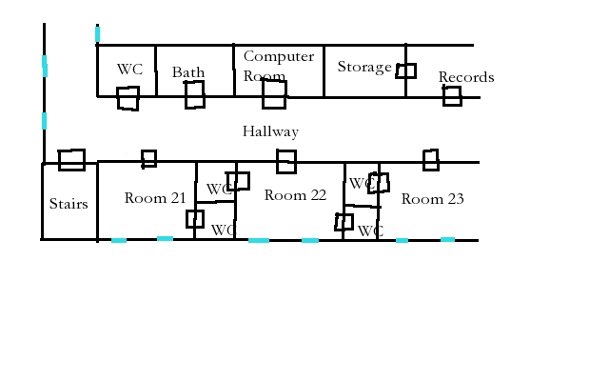

## Scene 03: H&P Systems

Harry Smith and Phil Jones office for H&P Systems is not far from St. Mark’s hospital and is in a small strip mall and is just a few offices and a small computer room. Harry and Phil are quite relaxed now that Mr. Love has made his latest payment as partner and that his DRaC software and systems are working without issues. There software is very basic and they don’t charge a lot for it. If the setting is back in the 70s the system uses punch cards to represent inventory changes. A card is made for each transaction so when five items are used five cards are processed in the system (assuming an IBM System/3). If the setting 80s and 90s then barcode readers are used instead of punched cards, but the systems are not much changed. If more modern then the software will use scanners on smart phones and other “shinny” devices and servers are virtual in the cloud. Harry and Phil are oblivious to the evil that has possessed their systems. They have very lax physical security and very weak password security—they have the passwords locked in a cabinet marked, “Passwords.” They write materials management systems and not anything that handles secure data. Harry is known to say, “You can learn the quantity of q-tips if you want.”

*A little research and a few calls to “supplies-of-information” sources that are not to be identified you learn the address of H&P Systems office and even manage to get a little bio on the company. H&P are Harry Smith and Philip Jones and they created the company just recently to sell a small material management system for hospitals. The software is very basic but all parties who purchased say it works without flaws or failures seen in other software like it on the market. Harry and Phil are always available to come and fix anything. Harry is a great teacher and soon as the users of the software going on their own without any issues. Phil is the main coder and a bit of a nerd. He is also very good at understand the users issues and new needs and is known to quickly whip-up the new features. Harry then goes to sell those features to the other customers. Effectively Harry and Phil are paid to improve their software and get to sell the changes again.*

*Trading some of the trade papers and ads from H&P systems, the software runs on the middle to low tier modern computers or cloud computing if the setting is current. From accounts from reviews, the software uses very basic code and does not seem to be more than well what two guys could cook-up in a small company. There was some concern that Harry and Phil, noted in a small article when H&P was not able to pay some bills, were in trouble as they had expanded to fast and had made too many capital investments, but now the company seems fine. A Mr. Love made a significant investment in H&P Systems, the new partner being accounted in the local paper clips you are able to get, and added the new DRaC, Data Retention and Calculation module, “a state of the arts real-time inquiry add-on the existing H&P System’s software.” This new module has given H&P Systems a “competitive advantage” and is what sold the purchase to the last few hospitals. A note found in an award banquet article clipping suggests that Mr. Love did not come and is a “silent partner.”*

The office is in a strip mall and is just a class door with H&P Systems printed on it. There is a small reception area with nobody there and Harry or Phil will usually hear the door and come. They also have Gary Cho as a computer operator for settings in the 70s or 80s or as a tech support for later or current settings.

**Harry Smith:** Mid-aged man with a family and technical background but enjoys selling more. Tall and high-school quarterback fading to middle age look and friendliness with sandy hair with no sign of gray and wrinkles from smiling too much. His office is full of motivational books, family pictures, sales pamphlets and manuals for their software. He often is re-reading one when in the office and making revisions and suggests ways to improve the software to Phil and Gary. Harry’s sales pitch is that what they have is good and they can work with you to make it even better.

His office is made up of used but nice wooden desks and chairs. A filing cabinet contains the reports from their accountants and their client list and contracts. Their contents are described more in Scene 05 below. If the agents manage to get access during the day the Director can skip down to Scene 05 to get the descriptions of the contents.

If questioned by the agents Harry will be friendly and make them coffee, but if they are not hospital officials looking for software he will quickly find an excuse to have the agents leave. If the agents try to pretend to be from a local hospital he will suspect them to be reporters and will be polite and tell them why everything is great and features of their software. The agents might notice that Harry never mentions DRaC and has only a few brochures on this software. Harry will of course call it brilliant if they bring it up. Mr. Love will be not mentioned and if brought up by the agents he will just say Mr. Love is not there.

**Phil Jones:** Phil is a computer nerd and even if the setting is in the 70s before the name of “computer nerd” was coined, Phil was one. He is a heavy-set man with little hair and a beard that frames is large face. His wired frame glasses suggest an alignment with the 60s but actually he is a hunter and member of NRA and has a gun in his desk draw. Phil loves to code and to talk to users to find new uses for his software. He will not speak to the agents unless they can talk code and systems. Depending on the setting his office is filled with punch card decks, tapes, or various out-of-date and not working phones and other “shinny” products. Phil has no idea how DRaC works and is not interested in it. Mr. Love turned down all of Phil’s ideas and ignored his questions.

If the agent’s reason for talking to Phil has something to do with computers and can keep-up with Phil they will quickly learn that the only “magic” in the materials management system is actually Phil. He is willing to spend unlimited time adding new features and swatting the occasional software bug. The software is just basic development with Phil putting in all the work to make it work. There is no real magic. Phil will send any questions on DRaC to Harry.

**Gary Cho:** Gary is another younger computer geek. He monitors the systems and updates the documentation. He also codes under Phil’s direction and usually debugging a problem or updating manuals or sales material. Gary impression is that he is a bit busy and will always talk while working, a multi-taker to the extreme. He is not married and seems confused about relationships and how to create them. Gary just likes computers and computer people. Gary will talk to the agents about anything. He is sure the DRaC software is written in some low level computer language as he cannot find the normal elements of running software on his servers from DRaC. He is also sure that it monitors the users and makes adjustments in a very dynamic way using some artificial intelligence or heuristic algorithm. Gary would really like to do more with DRaC, but Mr. Love is rather secretive from what Gary has seen of him. Gary will likely mention that the DRaC system exists in Mr. Love’s office across town and it is a remote site and connections by phone line or internet (if a later setting).

**Computer room:** If set in the 70s the IBM System/3 looks like a computer desk out of an old science fiction movie or TV show. Card punches, readers, and decks of cards are everywhere. Gary sits proudly at the computer desk. If in the 80s the IBM hardware is blinking off-white wall of hardware with tape drives and tapes everywhere. Gary is at a desk with a terminal. If current then the room is full of flat screens that show the status of the cloud servers and connections and users using the software. A few portal disk drives are available to copy systems to move them. Gary is in front of the screens eating popcorn, the only real hardware is the popcorn maker in the current times.

DRaC is connected to H&P Systems so that Gary can monitor it. The computer vampire actually monitor’s them and has left Gary alone for now. The computer vampire does not want to upset the status quo. He can raid the hospital for victims. Mr. Love installed “disaster recovery” at the H&P Systems and has hardware there that is suppose to be back-ups. It is copies of minions. So if the setting is the 70s there is a stack of cards set in a reader marked “DRaC” with automatic reloading hardware. If the 80s and 90s then there is a tape drive with a tape mounted that has “DRaC Ms” written on the tape. If more current then there are some hard drives marked the same way plugged in or using WIFI. Mr. Love and the computer vampire have secured H&P Systems and will use the minions as needed.

**Security:** Just locked doors are used to secure items. Passwords are kept in a notebook locked in a cabinet by Gary. With access to the notebook the agents can “hack-in” but it not very interesting software. There are no passwords for DRaC listed. There is an address of Mr. Love’s office and computer connection information (again depending on the setting).

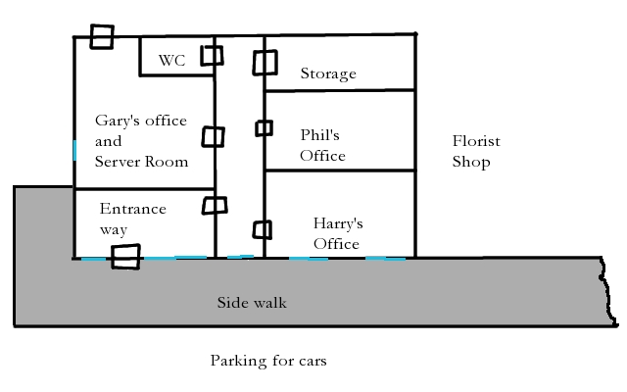

## Scene 05: An Unscheduled Visit to H&P Systems

There is no security to speak-of at H&P and the agents way want to visit the offices when the can search it without risk of detection.

*The offices are dark and the lock gives away easily to a pick or to a set of locksmith tools. The offices are all unlocked. The only lights are blinking status lights from the computer equipment. The office is a bit cold as the heat is off.*

Harry’s office contains the books for the company. It takes only a few seconds to find a few letters from their accountants at Easy Book saying they are over extended and are in danger of failing. It seems that Harry and Phil purchased various items at a deep discount recently and have a cash flow problem. A Mr. Love buying a 25% of the company solved the problem and also supplied new DRaC software to add to the product line. Mr. Love’s office is across town and is listed in the purchase agreements. It is easy to tell that Harry and Phil are running very barebones still. Contracts show that only St. Mark’s has the DRaC system but there are three other hospitals that will add it to their software in the next few months. There is very little information on Mr. Love in the files.

Phil’s office contains nothing more than a gun in the drawer and books and manuals. He also has a secret supply of instant food with a survivalist pamphlet. Phil also has various ads for emergency generators and a breakdown of the electrical panels of the office with notes for required changes on his desk. It appears that the generator is planned for a few months from now.

Gary’s desk contains a locked cabinet of passwords that are administrator level and would allow full access the material handling software but nothing on DRaC. They will find notes of Gary trying to hack into DRaC and that all his attempts failed, “AI is very good at avoiding me” he write in the notes.

The computer vampire will notice the agents and will send minions against them. It will wait until they are near Gary’s desk and then load the minions.

*While you are near Gary’s desk there is a sudden bust of static. Some of the computer equipment seems to be running. A huge burst of static and three persons, eyes looking like a TV channel full of white noise, appear in a burst of static and shamble towards you. The computer equipment still is spinning and running.*

**Minions:** Three at first and then adding a new one each round until there are as many as there are agents. Any minions that are destroyed are reloaded automatically and appear again as many as one a round. The agents’ only hope is to damage the computer equipment with gunfire or other attacks—like turning off the power at the switch box. There is no emergency generator

## Scene 06: Mr. Love and Company

A small office exists in yet another strip mall across town from H&P Systems. The office is closed and some junk mail is rotting near the entrance. A note on the door says that Mr. Love is travelling and will return soon; there is no date and the note shows so aging.

*The office is closed and the rotting junk mail dumped by the front door suggests it has been a long time since it was opened. The office appears to be part of the strip mall but it takes no time as to notice that the building actually reinforced brink and the roofline is different under the façade and is a pour concrete flat roof. There is only the one entrance. The power to the building is buried underground. Vents are all metal and set in the cement or brickwork. Some banks are likely easier to get into. The only advantage is that nobody is really paying any attention to the office as it has been closed for so long. A note on the door inside the glass door states in clean typing on a plain sheet of paper “Mr. Love is unavailable and travelling and will return soon.” It is a bit faded.*

Investigation will show that office is leased and that the lease is paid for the year in advance. Mr. Love is described as a short guy, heavy set, graying hair, wearing an old fashioned but very nice dark suit with vest, affects a strange eastern European accent, and a perfect gentleman with perfect English. “You will know him when you meet Mr. Love,” is the description given by a slightly star-struck 30-something realtor, Debbie Steward, who met him and closed the deal on the office. “Wonderful!” she says.

If the agents search for it they will discover that there is significant batteries and back-up power in the office. Permits show that the electrical system is high voltage and includes battery backup and a generator exhausts to the outside but is kept security inside the building. Walls are brick with reinforcing rods and the ceiling is poured concrete too. Any agent that claims detailed knowledge of computer security would call the office a vault to protect servers and not an office. The office is a fake.

Mr. Love error is that by having nobody at the office means that the locals have gotten use to ignoring it. The agents can easily pretend to be painters or other workers and pick the door’s lock even in broad daylight. They will discover that the door seen in the foyer leads to a steel vault-like door with a keypad. More information follows in Scene 07 found below.

The power lines and communication lines to the office are buried and well protected. Mr. Love bribed some locals to let his folks install his own lines and they are buried deep and in steel pipes covered with cement. Without explosives the agents will not be able to cut the power or communication lines to the building and any attempt will likely impact the local power and cause the utility workers to appear and to repair the power and communication lines. The Director may be honest with the agents that the vault is quite secure and that any disruption of power to the office they may attempt will likely get them in trouble with local utilities.

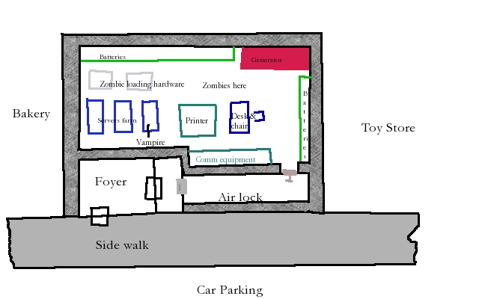

## Scene 07: Computer Vampire

The agents have finally found the source of the troubles at St. Mark. Something is not right with Mr. Love’s DRaC software.

*The abandoned office leads to a bank vault door with a keypad. The keypad is not even connected. Obvious Mr. Love’s computer systems are carefully protected behind this door.*

### Vault door

The door is a metal door that is locked by bars that reach deep into the cement walls. It is as strong as a bank vault door. The computer vampire controls the door and will ignore any combination that agents use as it is aware of their intent. A jack that bends it or old-fashioned explosives can only pass the door. Behind the first door is yet another metal door like that on ship, it is actually military surplus, and it will absorb the shock of any explosion and keep the dust out of the computer room behind the door, an airlock out of a science fiction movie. The players will enjoy blowing something up. It will take considerable skill to not blow out the windows of the façade or alarm the locals.

### The Server and Computer Vampire

The vampire is ready for the agents and is in physical form with as many minions as half of the number of the agents. The room is just a larger server farm for the “cloud” if the setting is modern. If not modern then an appropriate punch card, tape drives, printers, and so on are also found here. A large racks of batteries, looking like car batteries, are against the wall and a generator is also in the room with AC units too. The room is just a large server area. No chairs and no lights. The only light is what the agents bring with them. This can put the agents at a disadvantage as the vampire and minions can see in the dark.

**Computer vampire and minions:** The computer vampire is in its physical form and has minions already loaded that total half the number of the agents rounded down. Again, if the computer system can be damaged the creation and re-creation of minions can be stopped.

### Removing the Vampire

The computer vampire is not slain until its box of earth is destroyed. It is placed in the main server and appears to be an extra back-up battery-pack in the server including some fake wires leading to it and a red-blinking light. Only an agent with occult knowledge or careful knowledge of the server would discover this. Unless the agents have some occult knowledge or have seen too many Dracula films they miss destroying the computer vampire and it will rise again.

## Scene 99: The Vampires

**(Wild Card) Vampire, Computer**[5]

The use of certain computer equipment “feeds” the computer vampire. The computer vampire is forced by its bindings to perform computations and calculations by special program that make the software unnaturally fast and since the vampire is intelligent can make the software appear to be “artificially intelligent.” Actually the vampire possesses the system instead.

A computer vampire is “installed” by placing a small box of the grave dirt into a computer server and then casting a complex spell to convert an already existing vampire into computer vampire. As the vampire is slaved to the computer and now must follow special programs and instruction, it will not willingly undergo such a conversion. Once the spell is cast the vampire disappears into the computer server. It cannot act until its base control program is running on the server. Once the base program is running the vampire is “loaded.”

Once translated the vampire may only form physical form for a short period of time (a single battle) near its server and installed box of grave earth to defend it. It will be full strength each time—it takes no time to heal in the computer. Unlike vampires listed in SW the computer vampires are affected by normal combat and if a vampire is incapacitated it then dissipates into dust and static. It cannot reform until its base program is reloaded which is usually done by a computer professional. The server will show a ‘divide by zero’ failure of the base program and then a normal program failure (a dump and message on old IBM systems, message on a console or in a logging file for UNIX/LINUX, or the modern device will need to be powered-off and restated after a ‘blue-screen-of-death’ or a more polite message from other ‘shinny’ items to request a restart). The reload of the base program is loaded from a punched card deck, a tape drive, running an application, command-line at root, or other option based on the server. Once running again the computer vampire is back to full strength and can rematerialize to defend its server.

The box of earth in the server cabinet is usually disguised as some random bit of electronic gear. Its removal and exposure to holy water, holy symbol, sunlight, or just scattering to the wind will destroy the vampire and release all captured spirits.

**The Electronic Terror:** The vampire drains the users of the possessed hardware, even a remote user, by using mystic symbols that flash between screens and refreshed. A user of a possessed hardware might see a few strange symbols (notice skill) and if skilled in mystical knowledge might be concerned about the effect of the symbols on the user. The vampire uses these symbols to slowly fatigue its victims. The victims will not notice the effects and will not be convinced that they are fatigued and will continue to use the devices and software. If a victim is not a Wild Card it will be completely consumed by the computer vampire once it is fatigued and become a computer vampire minion (see below). This is at the computer vampire’s choice. The computer vampire usually only has a few minions as they require storage and it is unwise to remove all the victims—they comeback and feed the vampire again. Wild Cards make an opposed spirit roll and if the vampire succeeds the Wild Card is fatigued. If the vampire gets a rise then the Wild Card is unaware of the cause. If the Wild Card has a raise then it is clearly aware of the attack and that it came from the computer. A Wild Card that becomes incapacitated from the computer vampire attacks (unlikely to happen) becomes a minion and disappears.

**Attributes:** Agility d8, Smarts d8, Spirit d8, Strength d12+1, Vigor d10

**Skills:** Fighting d8, Intimidate d8, Notice d6, Shooting d6, Swimming d8, Throwing d6, Tech Ops d8

**Pace:** 6; **Parry** 6; **Toughness** 9

**Special Abilities**

* **Claws:** Str +d4 electrical damage.
* **Level Headed:** computer vampires act on the best of two cards.
* **Invulnerability:** computer vampires can only be damaged at their central server where they can form into a physical form.
* **Undead:** +2 Toughness; +2 to recover from being Shaken; called shots do no extra damage.
* **Server-based Undead:** The computer vampire may form a physical form to defend its server. It appears near the server as its move. If incapacitated it disappears and cannot act again until its base program is reloaded and the server will show a program failure in logs, screens, etc.
* **Vulnerability (Grave Dirt):** The destruction of the grave earth box installed in the computer server (see above) by normal means or by exposing to sunlight or holy water or holy symbols destroys the vampire and all minions are restored to their original form. Usually the server crashes and restarts, cards and tapes and hard drives go flying as the minions are rematerialized with no memory of being minions and restored to normal.
* **The Electronic Terror:** The computer vampire can drain users of its possessed computer hardware or application. Any user, at the computer vampire’s choice, can be drained. An opposed roll based on spirit. If the vampire succeeds the victim is fatigued. If the victim is not a Wild Card the vampire can select to consume the victim. The victim disappears and is stored on some media in the computer and maybe used as a computer vampire minion. If the non-Wild Card is not consumed it is aware of the attack and just assumes he or she has a cold or other excuse. Wild Cards are fatigued if the attack succeeds and if a Wild Card is incapacitated then he or she is consumed as above. If the attack on the Wild Card includes a rise the Wild Card is unaware of the attack and will continue to use the possessed application or hardware.
* **Symbols:** Any user of a possessed hardware or application might notice the strange symbols that appear for a instant on the screen as screens change. If the viewer has mystic knowledge they know that they symbols are magical on a successful skill check and if they get a rise know that the symbols are not very healthy to view.
* **Loading Minions:** The computer vampire can summon its minions at any location that contains a possessed computer application or hardware. The minions are loaded and then appear and do tasks demanded of them by the computer vampire. They are in effect mindless programmed zombies. The process to load a minion will have a stack of cards, tape drive, hard drive, or other physical device run and “load” the minion. For a 1970s setting, a card reader will start running and each deck will create a minion with some static discharges and other special spooky effects. Tape drives are available for later settings and hard drives for current times. It should be obvious where the minions are coming from. An attack on the hardware would of course stop minion creation. The loading of a minion takes no action and can be done once each round; the vampire just wave a hand or other gesture and cards load, hard drives spin, and so on and static builds and “pop” another minion appears.

**Minion (Zombie)**[6]

These minions are stored individuals that the computer vampire consumed and decided to store and are ready to use. The appearance is “zombie-d” version of the original person with some static and TV like static in eyes. They are undead.

**Attributes:** Agility d6, Smarts d4, Spirit d4, Strength d6, Vigor d6

**Skills:** Fighting d6, Intimidate d6, Notice d4, Shooting d6, Tech Ops d6

**Pace:** 6; **Parry** 5; **Toughness** 7

**Special Abilities**

* **Claws:** Str +1 electrical damage.
* **Minion:** They are “taken-out” when they take any damage equal or greater than their toughness.
* **Relentless:** Minions are immune to Fear or Intimidation and will carryout the computer vampires wishes without concern for the minions welfare or consequences of its actions.
* **Reload:** A specific minion may only exist at one time, but once “taken-out” the computer vampire can just reload it and bring it back.
* **Undead:** +2 Toughness; +2 to recover from being Shaken; called shots do no extra damage.
* **Server-based Undead:** The minion is stored in some computer media appropriate for the setting and must be loaded and then appears. If the media in damaged, unplugged, and so on then the minion is not available to load.
* **Weakness (Head):** Successful shots to the head “take-out” the minion.
* **Computer Vampire Connection:** Only as long as the computer vampire that created the minion by consuming a victim is not destroyed the minion exists. When the vampire is destroyed the minion are restored to the previous state and have no memory of being a minion. This restoration is usually full of static and flying computer parts (see above).

## Epilogue: The Hanged Man

The agents will have learned about the computer vampire and may have fought it and possibly destroyed it. If they have completed their mission to remove the threat they should be happy.

For the director to use as appropriate:

*A newspaper article mentions that H&P Systems have sold their software to an additional five hospitals. They have decided to no longer support the DRaC software. Phil Jones has written a replacement for the DraC software and incorporated the changes into their existing software.*

*In another article it is mentioned that an office was vandalized and some important computer equipment was damaged or stolen. The owner, Mr. Love, has not been able to be reached so far. It is believed to be the work of some inexperienced thieves as nothing of value was taken. The local police department is not releasing any additional information but asked for public for any information.*

If the agents destroyed the computer vampire the will get a note from Dr. Raj Smith, he sent it to the address he connected with the agent’s cover and was intercepted by the agency, that the hospital seems to have lost its “evil spirits” and thanks the agents, whoever they are, for fixing the “pipes.” Dr. Raj Smith says that he does not know who you are but that you are always welcome at St. Mark’s.

# Mission: The Tower

The tarot card is *the tower* and this card is associated with violent change and upsetting the normal order.

The mission is about an alien showing up in an autopsy and the investigation of what happened and the reaction of the aliens to the loss of one of there own. This starts at the St. Mark’s hospital from the previous mission thus creating a link between the missions.

## The Briefing

The agents receive a short briefing in writing.

*The agency has been contacted on a new item from St. Mark’s. Dr. Howe, a former agent, has asked for an investigation.*

*The agents are ordered to St. Mark’s to investigate and to take action as needed.*

*Knowledge of the threat and its resolution is restricted to agency personnel. Do not become involved with local officials. Dr. Howe is not to be used as an asset; he is retired.*

*Again in the unlikely event that the tarot deck be discovered (alpha grade occult power), do not approach—contact the Agency.*

## The Mission Profile

The agents are in the open and should act with discretion and should not be in the press or in trouble with the local officials. The agents should be armed and prepared for a paranormal threat.

Threat: Aliens unhappy.

Mission: Investigate and remove any threats.

Parameters: Locals must be kept from knowledge of threat and its resolution. Aliens must not be angered.

Supplied equipment: The agents are assumed still in St. Mark’s area so cost for normal expenses for travel in the area is covered. In addition agents may receive the following *perks:* cover identity, disguised gear, emergency contact, and one clip of modified rounds (Runic) (AoO page 59).

All other gear is available except air strike.

## Scene 01: Back to the Morgue

*The morgue at St. Mark’s Hospital is in the basement and run by the eccentric Dr. Eugene Howe who is never in if you ask anyone. You reach the morgue by following the signs and find Dr. Eugene Howe lying on a slab and apparently asleep; your entrance through the un-oiled and loudly squeaky doors startles him awake. He rises from his slab without comment and manages to do it without comedy. Dr. Howe is wearing a white lab coat with no name on it over his usual old and messy suit. His badges has a picture of Prince Charles of England for its photo next to the name “Inigo Montoya, Dept: Finalizing Accounts.” He smiles and says, “strange case for you.”*

*He points to tin foil and produces a tin foil origami hat from his lab coat pocket. Dr. Howe puts on gloves and waits.*

The director now asks the players if their agent makes and wears a hat. The director might supply tin foil for the players at this point and let them make hats if they wish. Once that is all done the narrative goes on. The might suspect Dr. Howe of not being serious (they would be right) and make a Smarts or other check of six or better, they know he is joking. A raise allows them to decide to join in with the joke.

This section should likely be paraphrased:

*After a short wait another man enters looks around and either swears or smiles. If the agents are wearing tin foil hats the man pays Dr. Howe ten bucks. If no hats or just one then Dr. Howe pays the man ten bucks and congratulates the agents for not being gullible. If the agents fall the trap Dr. Howe just shakes his head and says, “In my day as an agent I would not fall for that; actually I did fall for that!” He smiles and goes on no matter the results of the hazing.*

This section returns to the matters at hand:

*He pulls on a drawer in the wall and one of his most bizarre “customers” is pulled out on a slab covered with a white sheet. The smell of earthiness and not rot fills the area. The doctor pulls back the sheet and a classic “alien” body is seen. The hairless head, large eyes, and tiny mouth are seen. The sheet is pulled-back more and the large short chest, with a “Y” seam sewn back together from an autopsy, is seen with short legs that look very human as does the arms. Dr. Howe looks at you all, smiles, and says, “Not alien.”*

*The doctor points out various items on the body that are not alien but twisted human. “Who ever this was they died hard,” he says. He looks at you a bit grim, “If you find them, don’t be nice.” Doctor Howe continues explaining how the body was twisted by bits of “undead” energy and some obvious biological forces. “Some one messed with something biological with some bad juju,” he finally concludes.*

*Lastly, he hands a tarot card, The Tower, to you wrapped in tin foil. “That appeared in the drawer with the body,” he says with a blank expression. “Its power seems to be used up,” he says in a flat controlled voice. “I think there is more than one story on going; I am retired,” he says in a controlled voice. “Go, investigate, and don’t upset the locals or ET!” he calls out after you as you leave.*

The agents return to the hospital to meet with Dr. Eugene Howe at the morgue. Dr. Howe is still as paranoid as before (see above for a description) and if he met the agents before he will ignore any obvious signs of identify change and even if they met the doctor he will pretend he has not met them before. The facts are that he contacted the Agency after the body appeared and was expecting the agents. His old contacts from his previous job are still good and they respect the fact, and may be relieved, that he wishes to remain a private citizen now and remain retired. The good doctor has a strange case to share with the agents.

The doctor has a “guest” in the morgue that appears like a classic alien with the long arms, baldhead with oblong eyes. The body was found by the side of the rode, naked, and appears from basic forensic data to have been dropped there. The body shows no obvious cause of death and Doctor Howe did an autopsy. This “alien autopsy” concluded that the body is actually human and that a terrible transformation has made it appear “alien”. This discovery has not made the good doctor more stable. He is now using another badge and is often dressed as a janitor instead of a doctor. His badge reads “Inigo Montoya, Dept: Finalizing Accounts.”[7]

The body is human and is the destroyed remains of Jack Schmidt and if the agents determine this the good doctor can verify this with work out the name dental records that the body is Jack Schmidt. Jack was slain and changed by necromantic mushrooms. All of this is covered in more detail in Scene 03. Dr. Howe wants to identify the body and have the agents find some justice for the victim. The doctor has no more interesting information for the agents but is willing to help them with making more hats from tin foil if it will make them feel better. He does suggest the agents checkout the roadside where the body was found. He offers more tin foil, “Might be a surprise out there.”

## Scene 02: Crop Circles

*The location is in the farms near the hospital and in effect nowhere interesting. There is however a large group of folks nearby looking at a field of grain. It appears that there is a large crop circle in the field. You are beginning to think about that tin foil hat. There is a large 100 foot circle in the field with two arms branching out with semi-circles on the branches. There appears to be a bemused farmer getting his picture taken and another photographer on a very tall ladder trying to get a good picture of the artwork in the field of grain. A few folks are wearing tin foil hats.*

The agents are sent to the location where the body is found, a roadside, and there they find bemused farmer and some local press: Farmer Brown has crop circles. The farmer is harmless as are the crop circles that if understood correctly says that we aliens have nothing to do with this. The circles points to areas where the aliens have detected strange occult powers that may be involved. The aliens want nothing to do with local politics or occult issues.

The crop circle is about 100 feet across and is in a wheat field that is tall enough to make the crop circle clear. At the center of the crop circle is solid section of pushed down wheat that radiates out twenty feet and then a few feet and another circle that is broken at three equal places not on the two lines that also radiate out from the center. The two circles mean in crop circle language, “we are not involved.” The two lines that radiate out are equal distant in length, about 500 feet, but have a series of arcs of circles on the line. The last arc is reversed. The lines if copied to a map would intersect with Jack Schmidt’s house, scene 03, and Tim Jackson’s house, scene 04. The arcs that are “in orbit” of the center count the number of miles out on the line—the crop circle assume the local measure of length, two and five, and the last reversed arc is a measure of the fraction of the last mile. The measure is made my figuring the ratio of the location of the last arc on the line from the previous arc. The line pointing at Jack Schmidt’s house is 3/4 the length of the section of line and thus ¾ a mile and Tim Jackson is ½ a mile and is at the half-way point.

The players may find this a complete mystery if they cannot speak “crop circle.” Any player who has a background story that includes “aliens” can take a shot at it—Knowledge (Paranormal)[8] also will work. Also anyone with a map can draw out an extended line and this might be noticed to connect with some local farms. Some more research would notice that one lines connects with Jack Schmidt’s house. This is up to the players to explain how they can understand the crop circle to the Director.

If the players decide to test for extraterrestrial evidence they will find a hint of radiation at the center of the circle, a light dose of alpha particles, and some light-colored sand that if carefully collected and then tested will be found to have unusual ratios of isotopes and carbon structures[9]. The sand is extraterrestrial. Pressure points can be identified under the pushed down grain that was generated by something that weighted a few tons or more. All suggest that something very odd landed in center, made a crop circle, and left farmer Brown a bit unhappy. The local bakery has offered to buy all the grain from the field and make “space loafs” from the wheat.

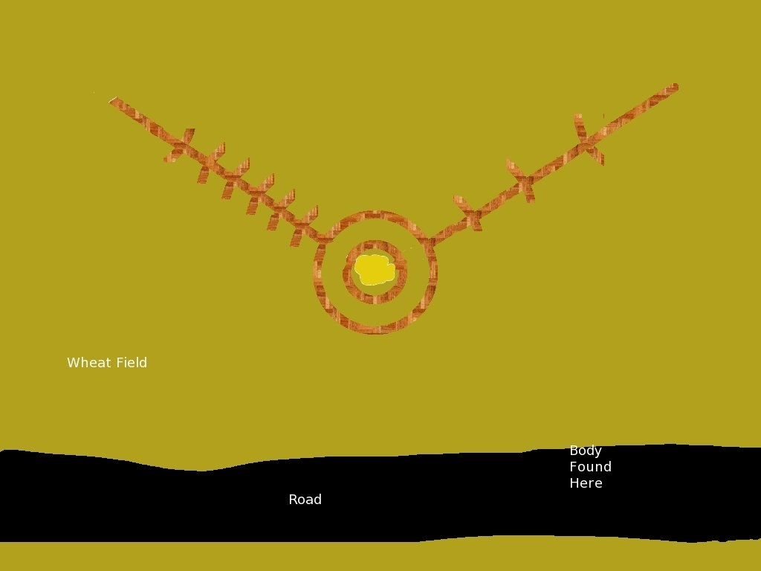

## Scene 03: Missing Local Man

*A prefabricated home on a cement basement with an uncut lawn and mail accumulating on the porch suggests nobody has been home for some time. The house is recent and well maintained. The lawn and bushes appear just recently to be uncared for; like someone is on vacation for longer than expected. The junk mail goes back only a week or so, the local free “Penny Saver” trading has a date on it. There is a sign on the door, “If not available, come in and harvest.” The mail lets you figure that Jack Schmidt lives here and likely lives alone. You decide to enter.*

*If a hippy had to have everything clean and in its place this is what it would look like. The psychedelic 1960s-early 70s posters are all matted and framed. The bead curtains match. The floor is shag and vacuumed. The dishes are put away and the kitchen shines. Magazines, Mother Earth, Rolling Stones, and Transactions of the British Mycological Society are all on a shelf next to various mushroom text all in order of date and then alphabetical[10]. The lava lamps are matched in each room to the color of paint and bedding. It is a well loved and orderly home.*

*A search finds orderly files on mushroom production. A ledger of sorts is found on a small table before the door to the basement. A ceramic bank is next to it in the form of mushroom with a very proper looking caterpillar smoking a hookah. There is money inside, a lot of money. The ledger appears to list purchases made while Jack was out. He appears to have been out for a week.*

*The ledger lists each person, a very strange name such as “Happy times,” and an amount. Most amounts are under five bucks. One person, Lisa, lists “cleaned house” as payment. Mr. Love catches your name and he seems to have taken many small cost samples and on one occasion a large purchase of something called, “California Dreaming.” A search of a desk finds tax records and careful receipts. There is a note from the sheriff office on proper sale of medicinal herbs and record keeping.*

Jack Schmidt has been missing for some time. Jack owns a small few acres of land with a manufactured home sitting on the land by a local road. A dirt drive way, power pole with the ubiquitous mercury light, and a wellhead shows this to be a minimal cost home. Jack has discovered growing exotic mushrooms and other plants and making enough to get-by but not get rich on his exotic plant and mushroom sales. If he had been less of his own customer and more a farmer he would be richer and still alive. Jack’s mushroom became a bit too exotic and he was transformed and the shocked killed him. Jack’s customer’s found the “alien” body at Jack’s place and dumped it far away from the area. They believe that Jack was “taken” or ran away. They customers are leaving payment for mushrooms that have been harvested in a jar—this was the agreement when Jack was unavailable either physically or mentally. A book next to the jar has names and purchases. As none of this is illegal, the ledger helps Jack with his taxes and working with local officials. Mr. Love is listed multiple times. He gave the “seed” money and collects samples for his lab. Tim Jackson is listed last on the ledger in Jack’s hand.

The real cause of the problem is the voodoo curse put on the mushrooms by a new local voodoo priest Tim Jackson. Tim was a bit upset that he had to pay for mushrooms and decided in a moment of anger to curse Jack’s new group of mushrooms. Jack had harvested them from the graveyard not knowing that Tim was going to use them for a rite. Tim convinced Jack to try one. Jack’s death was a bit of a surprise to Tim who expected to have a new zombie slave. Tim, disgusted, left Jack’s body to be found by others.

For the agents they have walked into a difficult problem. In the basement is the mushroom growing and storage area. The cursed mushroom have a sign on them in the basement: “New Shroom, don’t risk it!” and until recently nobody was willing to try them. A group of hooligans entered Jack’s house and went into the basement without paying and decided to try the wrong mushrooms. The hooligans, being not good folks, were twisted by the cursed voodoo mushrooms and became undead mushroom zombies. They are now hiding in plain-sight as they look like mushroom cultures. The basement encounter is below in scene 04.

The agents will be aware that Jack is missing. That folks continue to pay Jack for product and help themselves. There is no sign of Jack and he has not been seen for some time. There is mail piling up and dust that suggest that Jack has been missing for some time. His disappearance is close to the time of the “alien” discovery. Dental records would be available for the corner if the agents suggest to him that the “alien” is Jack and would confirm the twisted alien-like body as Jack. Dr. Howe would then issue a death certificate for Jack.

## Scene 04: Mushroom Zombies!

*The stairs lead down to an earthy smelling basement. No smell of rot just a bit colder and earthy. There are some naked light bulbs on wires connected to wires that light the basement. The switch fills the area with light showing row upon of row of tables filled with dark boxes of earth with mushrooms. Many have been picked from what you can see; many are broken of missing. Fun signs are attached to many boxes with names like “Shinny Mornings,” “Amazing Colors,” “Vacation,” and “Head on Post” suggest that many of the mushroom are recreational. A sign saying, “New Shroom, don’t risk it!” ominously is push in a box of sickly green-grey mushroom that seem to glow a bit that appears to have been looted and only broken mushroom and new growth ones are left. Under some tables and across some tables are logs adn piles of earth sprouting the same awful looking mushrooms. Some boxes are knocked on the ground and it appears that something has recently wrecked a few tables.*

Hidden in the basement, a very small area, are mushroom zombies (see below in Scene 99) that are waiting for their first victims. They died from eating the cursed mushrooms as mentioned above. They are pretending to be tables and mushroom logs and so on. There are as many mushroom zombies as agents plus one more. It is very close quarters and the zombies are vicious and their *tripping* attack can leave the players open to attacks.

The zombies get a +4 to their hide as they are not moving and look floral in this setting (d6+4) versus the players’ agent’s notice. An ace from any agent allows the agent to warn the other agents in time giving them another +1 to their rolls and thus any agent that missed the notice roll by one then makes the notice. Any agents that fail will not notice the mushroom zombie next to them and is surprised[11]. The zombies and the agents are in close quarters and escape is difficult. This is a slug-it-out battle for the agents.

The bad mushrooms if studied by someone who is familiar with undead and necromancy will detect that the mushrooms are actually “zombies” of the mushrooms. They are not actually alive. The agents should take them outside and let the sun destroy them. A few hours in the sun will kill them. Of course lighter fluid and a match may be more certain! A supply is available in the house.

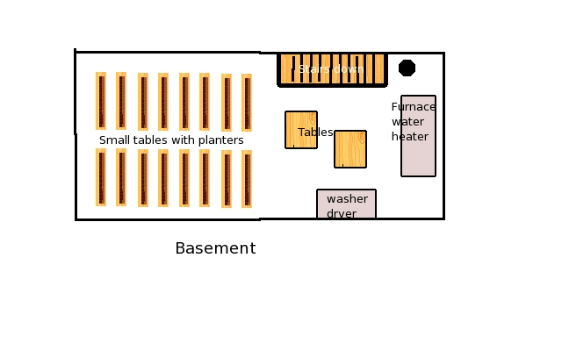

## Scene 05: The Voodoo

*A run down camping trailer is parked on a lot that has the remains of a burned down house. It appears someone has hooked up to the water and power that was once connected to the house. An outhouse is in the back lot as is a “camp shower” under a tree. Obviously you have found what we would now say is “living off the grid.” The area is full if “fairy circle” and some are toadstools rings that look ominous.*

Tim Jackson a mixed race from New Orleans has a light complexions and straight hair so passes easily for white and learned his magic and insanity in New Orleans. He is a wanted man in Louisiana for the murder and shooting of a man he suspected of being involved with his girl friend. Tim shot Tidas Smith from his car as the man was getting his mail and strangled his girl friend, Debbie Sparks, and dumped her body in swamps. Tim Jackson comes across as intense southern man that often talks to himself in conversations with others.

In the ground are some zombies that will instantly our out of the ground if Tim orders them to attack, a free action for him. He can also call up a mushroom earth element as an action in the area that has mushroom fairy circles; he can only do this once a lunar month so he will hold back this attack until he is worried. He lives in a small trailer so outside is pretty much where he lives.

If the agents come to meet him he will be paranoid and likely use his zombies on them holding back the elemental until things are desperate. He will try to be invisible and let his zombies work over the agents first and if that fails he will summon the mushroom earth element. He will use magic and gun as a last resort as he tries to run away.

**Tim Jackson (wild card)**

**Attributes:** Agility d6, Smarts d8, Spirit d6, Strength d6, Vigor d6

**Skills:** Channeling d8, Fighting d6, Knowledge (Mystical) d6, Knowledge (Paranormal) d8, Knowledge (Occult-Voodoo) d8, Notice d4, Shooting d6

**Charisma:** --; **Pace:** 6; **Parry** 5; **Toughness** 6

**Hindrance:** Delusional (Major)—believes he is a voodoo priest, Wanted (Major)—murder

**Edges:** Arcane Training (Magic), New Power

**Powers:** *bolt I, boost/lower trait, invisibility*

**EXTRA:** summon zombies as free action or Mushroom earth elemental as an action

**Languages:**English, French

Tim has a small revolver he may use, he has no easy reloads: Range 12/24/48; Damage 2d6+1; Rate of Fire 1; Shots 6.

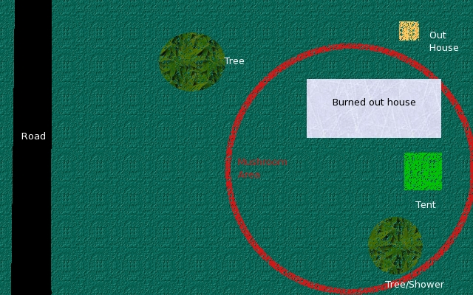

## Scene 06: Additional People

*The local police office is as expected; a small police force with mostly small town issues. A friendly man is Sheriff, Paul Coxs—called “Peacock” by everyone.*

The local police force is headed by Sheriff Paul Coxs, aka “Peacock.” He is a very approachable man and happy to help anyone with proper credentials. “Peacock” will know about some squatters in the area of the crop circle. He also has many kids recently caught up in a pot bust and heard about mushrooms and Jack Schmidt and his hobby. The sheriff does not approve, but Jack was polite and smart so the sheriff is just keep an eye on him. “Peacock” is proud that the township will have the cleanest parks and public toilets as he caught up six kids in a pot bust. “Instead of locking ‘em up and making them into criminals they are cleaning parks and toilets for the summer—we have really nice looking parks and toilets now,” he says with a sparkle in his eye.

*Information is available in the local library run by a middle aged gall, Mary Collins*.

The local paper is available at the local library. The librarian is Mary Collins. She is a middle aged gal that is nicely dressed. She knows Jack Schmidt quite well and is a bit worried as he is late on some books—he is never late. Mary orders mycology books for Jack and knows about his studies. She also can find that a house burned mysteriously a year ago and the family lost everything. They moved away and took the insurance money. Mary believes the house was never rebuilt and the land is still for sale.

## Scene 99: Monsters

**Mushroom Zombie**[12]

These are individuals that ingested the voodoo mushrooms and their natural evil tendencies grew and they became undead mushroom zombies. These are not minions and are a bit tough with the Tripping special ability.

**Attributes:** Agility d6, Smarts d4, Spirit d4, Strength d6, Vigor d6

**Skills:** Fighting d6, Intimidate d6, Notice d4, Stealth d6

**Pace:** 4; **Parry** 5; **Toughness** 7

**Special Abilities**

* **Claws:** Str and the victim is tripping (see below). The mushroom zombie often says, “shroom,” when hitting a victim or other appropriate words (anything except “brains”).
* **Tripping:** Any hit with claws and strange chemicals enter the victim and the victim must make a Vigor roll to take any action. Each failed roll grants +2 on the next roll. After making a Vigor roll the victim is immune to the effect. [13]
* **Fearless:** Mushroom zombies are immune to Fear or Intimidation. They will not seem to understand what fear is anymore. They might moan, “chill,” and ignore it.
* **Undead:** +2 Toughness; +2 to recover from being Shaken; called shots do no extra damage.
* **Weakness (Head):** Successful shots to the head “take-out” the mushroom zombie.
* **Floral Look:** In a floral setting a mushroom zombie can appear to be a log or a table covered with mushrooms. This gives them a natural light cover (+2) if moving in a “floral” setting or if not moving heavy cover (+4).[14]

**Mushroom Earth Element[15]**

The elemental appears inside a fairly circle and is an earth element combined with some elements of mushrooms. The mushroom earth elemental are as strong and have all the same attributes of a normal earth element, but include some poison in their attacks.

**Attributes:** Agility d6, Smarts d4, Spirit d6, Strength d12+3, Vigor d10

**Skills:** Fighting d8, Notice d4

**Pace:** 4; **Parry** 6; **Toughness** 11(4)

**Special Abilities**

* **Armor +4:** Rock hide.
* **Bash:** Str+1d6 plus Mushroom (see below)
* **Burrow (10”):** It can meld into and out of the ground.
* **Elemental:** No extra damage from called shots; fearless; Immune to disease and poison.
* **Mushroom:** A hit from the mushroom earth element sends out spoors into the wound that makes the victim shaken.
* **Restricted Movement:** It cannot leave the general area where it was formed. It has to be near the fairy circles at all times. Burning the fairy circles with fire will destroy the elemental.

## The Epilogue: The Tower, Saying Goodbye to Jack

*Dr. Howe invites you to the send off for Jack. It is a hippy version of a wake. The “alien” body was Jack Schmidt and he was cremated and his ashes mixed with various mushroom growing material. A service is done in Jack’s house’s backyard with it all decorated like a druid holiday. All the guests are wearing tin foil hats. Logs are stacked and the guests are offered to take one home. Jack’s mushrooms spoors have seeded the logs and so the guests can have a bit of Jack and his magical mushrooms too to take home. You learn that one was placed in Farmer Brown’s famous field and disappeared. “A nice thanks you,” says Dr. Howe who seems comfortable in a tin foil hat, carrying two logs, and wearing a nametag that says “Press, Erich von Daniken[16].” He smiles at you, “Thank you for bringing closure to this strange case, but I wonder about the card.” Dr. Howe leaves you thinking about the card.*

If an agent takes a log they can claim mycology as an interest if the agent has any remaining slots for interests[17].

# Mission: The Wheel of Fortune

This card is the *wheel of fortune* and this card is associated with luck. In this case a quack spiritualist and séance holder has started to have some real luck. Mr. Love needed some information that was more easily retrieved from the dead so he used the tarot deck to “improve” the skills a local quack spiritualist and conman. Once Mr. Love got what he needed Oliver Holmes went on to use his powers in some unique ways. He believes his powers came from the antique tarot card, the *wheel of fortune,* he keeps locked in a gun safe at his rented house

## The Briefing

The agents receive a short briefing in writing.

*The agency has been contacted on a new item from the local officials.*

*The agents are ordered to review the police evidence and determine if this is another event gamma grade occult power caused by an alpha grade occult power likely manifested in a tarot deck. The agents are to contain any threat and remove risk to the locals.*

*Knowledge of the threat and its resolution is restricted to agency personnel with limited sharing of intelligence with local officials. The agents are to act independent of local officials.*

*Again in the unlikely event that the tarot deck be discovered (alpha grade occult power), do not approach—contact the Agency.*

## The Mission Profile

The agents are in the open and should act with discretion and should not be in the press or in trouble with the local officials. The agents should be armed and prepared for a paranormal threat. They are to work with the local officials.

Threat: Apparent manifestation of occult powers at gamma or beta levels.

Mission: Determine of threat is real. Eliminate and/or contain threat.

Parameters: Locals must be may be used to assist and limited intelligence shared. Press is to be avoided and official records must not include any information on agents or agency. Failure to restrict records will result in a beta alpha incursion into the local record keeping and may require use of gamma gamma mystic powers to establish a cover story.

Supplied equipment: The agents are assumed still in local area so cost for normal expenses for travel in the area is covered. In addition agents may receive the following *perks:* cover identity, disguised gear, emergency contact, and one clip of modified rounds (Runic) (AoO page 59).

Again, all other gear is available except air strike.

## Scene 01: The Impossible Bank Job

*Local sheriff, Sheriff Paul Coxs aka “Peacock,” contacts the agents—he either met them or heard about them from the previous mission. He leaves a message that is routed through the agencies to the agents, “You seem connected to weird stuff, we got that.” Apparently a bank job has been done with an insider. The insider was buried last week. The Sheriff believes a more normal answer will be found, “but a lot of strange has been going on so some extra help is welcome.”*

The recent unexpected death of a manager of a branch of a small bank allowed created a new opportunity for Oliver Holmes. He held an séance and forced the dead bank manager to appear and forced the spirit to give him the safe combination and how to disable any alarms. Oliver than contacted a friend of a friend who knows a criminal who does break-ins, Charlie “The Tuna” Hook. He did the job solo and broke in to the bank late at night, avoided the alarms, opened the safe with the combination, took the available cash and left. A broken window from “The Tuna” suggested something was amiss. Money was found missing and the bank and police are puzzled. The lock is timed so the vault unlocks with a simple combination. Only the late bank manager knew the override combination and the makers of the vault had yet to send someone in to replace the combination. Depending on when the setting for the campaign is the vault may have a computer log of who opened it via their PIN number. The number used will be from the late bank manager.

The agents are sent to investigate the bank robbery and work with the police. The police are not happy and believe it is an inside job and that someone is making up something. That the late bank manager, Howard Hills, must have written down is combination or given it to some one else. Sheriff Paul Coxs, aka “Peacock,” may already be known the agents from the previous mission. If the know him already or introduce themselves. He will be happy to see them and will comment that they “only show up on the weird stuff, but he is happy to see them.”

Any attempts to find paranormal or mystical or odd religion energies or “other worlds” causes will fail. Someone wearing gloves broke in, knew where the alarms were, opened the safe with Howard Hills’ combination (or PIN if a later time is used for the settings), and took cash and only cash that are used and easy to get. No marked bills or other “alarmed” cash was taken. The safety deposit boxes were ignored. Howard Hills’ work area was searched and no notes or signs of notes of combinations and PIN numbers were found. The local police and Sheriff have no leads and think it is an inside job.

Note: The Director has no combat or specifics for this scene. In this scene the agents are working with the police to collect information.

## Scene 02: Blackmail Gone Badly

*New Report:*

*Local no-good-nick Charlie “The Tuna” Hook was found dead near a road apparently being slain by multiple gunshots late last night. The police are treating the shooting death as a homicide. Mr. Hook had been arrested for minor crimes over the years and was known to local sheriff office as a “troubled person.” The police ask the public to contact them with any information about Charlie “The Tuna” Hook. This is the second death of misadventure in the recent months.*

*Sheriff Coxs called the agents to see if they have any “special” information about Mr. Hook.*

A murder that suggests blackmail that went badly happens a few days later. Oliver Holmes and Charlie “The Tuna” Hook have been going through the obituaries to find targets for the séances. Charlie meets his end when he tried to use the information he learned from a recently slain informant to try to blackmail a local hood, Roger Smith. Charlie met with Roger in a public place, local McDonald’s, and explained that he knew about Roger’s pot smuggling operations and that he would stay quiet for a small one-time fee. Roger agreed to pay, but then used a rifle to end Charlie’s blackmailing attempt. Roger is a cold-blooded killer and a very good shot. He is also smart enough to know that a rifle shot from a distance is far better than a close-up pistol shot. Roger waited for Charlie to show up and shot him from a distance putting two rounds into Charlie’s chest—instantly killing Charlie. Roger picked up his spent cases, walked out of the area and used a rake to mess up his tracks. He walked to his truck parked at a local dinner and left. Roger replaced the gun barrel on the riffle and used a metal cable on the replaced gun barrel to make it impossible to use and to determine what bullets he generated. Roger is being very careful, as he does not understand how Charlie had learned his secrets that only the informant he murdered could know.

So Charlie is gone now and Oliver Holmes is scared. The agents are asked to help look into the murder of the local thug. It will not take much to find out that a local medium is related to Charlie, a cousin, now called “Sorry” Hook. The agents may want to look up Oliver. This information is not well known and would require a rise in the check to discover. The players and the Director should work out the best checks.

If the agents are wondering about some CSI stuff: Dr. Howe does the autopsy and his report is that a high-powered rifle killed the man. They have clean bullets to match but so far nothing to match them too. The shots were made from above, likely a bluff not far from where the body was found. The body was left where it fell. Charlie “The Tuna” Hook was reasonably well but showed some signs of drug use and his last meal was from the local McDonald’s. His truck was found not far from the site of his death and wrappers for his last meal was found in the truck. A look at the bluff found some odd rake marks.

Note: The Director and agents will have to role play this to share information.

## Scene 03: The Impossible Find[18]

*A strange headline in the local paper:*

*The local historical society has announced that it has received positive information on a lost cannon. It has been missing for 78 years and used to stand near the center of the city park next to the existing flagpole. If one asks about the cannon one learns of a legend that the old cannon was fired on the fourth of July each year until it was stolen. The story tells that something went wrong the last time the cannon was fired and a few folks were hurt. It is not clear how many or how bad. That night someone the story tells, often believed to be the Van Burn family, took the cannon and buried or threw the cannon in a lake. The legend states that these some ones considered it unsafe to use the cannon and wanted to save life and limb and removed the safety risk. The last Van Burn passed away a few weeks ago. There is a standing $1000 award for the local historical society for information that leads to the cannon’s return, no questions asked.*

*A note with a photo of a cannon underwater was sent with a request for the reward. The historical society will not release any more details. It is sure that the cannon will be soon recovered and the reward paid. There is some speculation that the last Van Burn may have left instructions in her will on the cannon—the family is silent on the cannon, as always for the last 78 years. A family member informed this reporter that nobody in the family knows the exact location of any things from 78 years ago—it is likely some one found something long lost. The same family member strongly suggests it would be unwise to try to fire the cannon!*

The agents find this odd news item interesting.

Years ago a local cannon was stolen from a park. It is a world war one gun that been sitting next to the flagpole for years. The town father’s put up a $1,000 reward to return the canon, no questions asked. It has been ten years now. It was assumed that the canon was stolen and sold for scrape and lost.

Actually the canon was thrown into a small lake and just recently one of the pranksters passed away and Oliver Holmes aware of the story tried his luck and learned the location of the canon. Oliver has written a letter explain the location and requesting that a cashier’s check be sent to a certain mail box in a town nearby as the reward—made out for cash; in the letter he explains he does not wish to be known and expects the “no questions asked” reward to be upheld.

The local papers and city celebrate the return of the lost cannon. The story was too good not to leak to the press. Olive Holmes is a bit concerned that the story “broke,” but he is greedy enough to continue with his plot to the reward.

The agents may want to follow the cash and discover that Oliver is the source of the knowledge about the cannon. They can “stake-out” the post office. Oliver does not believe any one would connect this with this other

## Scene 04: The Medium

The agents manage to meet Oliver Holmes on his own terms or at his shop then use this scene. If the agents end up in a battle then use Scene 05 with revisions as needed.

The Director may have to paraphrase or revise:

*A small storefront that is neat and clean and just a bit spooky offers “Readings” and “Tarot” in neon signs. The plate-glass windows are covered with curtains so you can’t see inside. Inside is a small room with an “office” through another curtain. A table, green and covered with felt, some un-matching wooden antique chairs and a deck of large tarot cards, used and old looking, fill much of the space. Bookcases line the walls and contain stuffed owls, plaster skulls, bottles with specimens in them, and the old books that on closer inspection are mostly old encyclopedias sets, everything to set a mood.*

*If the shop is entered Oliver Holmes will appear in a moment and welcome the vistors, “Welcome to my shop.” Oliver Holmes is wearing an old suit and a bow tie that is loose. His shirt is an old Victorian wing-tip collar white shirt. His shoes are black and shinny. He will be friendly and offer a “reading” to the vistors. “You can pay if you think it worthy,” he offers with a smile and a salesman’s well practiced patter.*

The Director can play Oliver Holmes as a role playing experience or the agents can make various skill checks.

Should Olivier Holmes be questioned and the subject of Mr. Love comes up and the agents convince Oliver that he is not being threatened he will answer questions. He fears the law now and will do anything to avoid suspicion. He will look nervous if “officially” questioned. He will visible become agitated if asked about Mr. Love.

If forced he will tell them that Mr. Love let him draw a card from a strange deck and he had his powers as long as he owns the card. Mr. Love used him as a medium then. He cannot recall his experiences. Mr. Love gave him this power and he has been able contact the dead.

Any attempt to ask for the card or to take with moves to Scene 06.

If the agents decide for a look after dark then Scene 07.

**Oliver Holmes (wild card)**

**Attributes:** Agility d6, Smarts d8, Spirit d8, Strength d4, Vigor d6

**Skills:** Fighting d6, Knowledge (Mystical) d6, Knowledge (Paranormal) d8, Knowledge (Local) d8, Lock Picking d6, Notice d4, Shooting d6

**Charisma:** 1; **Pace:** 6; **Parry** 5; **Toughness** 6

**Hindrance:** Delusional (Major)—he believes in the cards, Wanted (Major)—Roger Smith is not sure Oliver knows anything but that will soon change.

**Edges:** Attractive, Luck

**EXTRA:** May summon tarot skeletons for a battle and tarot ghost once a month

**Languages:**English, French, and German

Unarmed.

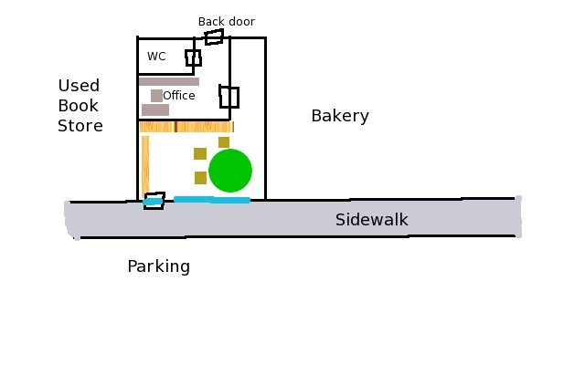

## Scene 07: A Little Night Action

A simple lock with the same key for the front and back protects the office and so is a simple entry. There is no alarm system.

There is nothing of interest of value in the “reading” area in the front. This is mostly a shame. The card deck is not on the table when Oliver is not present. He locks the deck in the safe. It is not valuable but he knows that hooligans would take it if given a chance.

In the office is more interesting. Oliver is reading about dead people, lots of dead people. The desk is covered with local newspaper cuttings of obituaries. There are also a few old copies of Who’s Who likely borrowed from the books store next door, Renewed Books. A look through files finds that Oliver is interested in the dead or the soon to be dead and well off or shady.

The Director could supply this information a bit slower:

*The desk is covered with newspaper cuttings. Seems not the sport page but obituaries and crime pages.*

*The files are not about customers and their readings. The files are on history and folks that are dead.*

Most “reading” and “tarot” cards readers keep detailed files on readings so that they can continue a consistent narrative. Anyone with who knows much about charlatans would expect files on customers. The missing notes and files would surprise an expert on charlatans.

There is a safe and Oliver knows something about safes; Charlie “The Tuna” Hook helped him with securing their information. The safe is cemented and bolted to the floor. It is not moving. It is an antique actually that was broken in from the bottom. Oliver got it for cheap and they welded new metal to cover the hole and then cemented and bolted to the floor. The safe is a circa 1899 Louis Contencin & Sons Round Screw Door Safe with combination lock door. It can be drilled, blown, or with careful work it can be felt-out and listened too and then opened the old fashion way. The safe is made of a lot of metal so it will take a while to drill it. The old fashioned way is at a +/-0 as the safe is old and well known to crackers but is well maintained so even.

The safe is protected by a curse. The any person or persons that are not Oliver or Charlie that removes anything from the safe will be attacked by the curse. They will see a vision that they have to over-come. The Director may find it more fun to affect all of the agents.

*The room fades out and you find yourself at a new scene of the old west and in the corner is the same safe open filled with old style cash and gold coins looking new. You are dressed to fit the period. You are at a table and Oliver is sitting opposite to you. He deals out a poker hand to each of you. It appears you have to beat the house, Oliver, with a five-card poker hand.*

The agent is being cursed and may resist the curse by winning a poker hand against “Oliver” as played by the Director[19]. The Director deals poker hands out (or uses other rules of his or her choice). There will be contest of wills that is done three times. Each success allows the winner another card from the deck. At the end the hands are compared. Anyone that has a hand lower than “Oliver” has the “Old West Curse” (see Scene 99 for more information).

The safe contains these items:

The tarot cards deck that is old but not magical or valuable.

Cash box containing $58.38 in small bills and coins.

Found is a note that contains the combination of the bank safe in Charlie’s handwriting.

A student essay notebook that contains notes in Charlie’s handwriting describing in detail Roger Smith’s illegal activities with bank accounts and explanations of how Roger Smith has committed tax evasion on his sales of pot; Charlie signature is on it, notarized.

A map, photos, and letter to request the reward for the cannon is found in a plain envelope.

A hand drawn sketch of Mr. Love showing a thin man with dark hair[20] was done by Oliver and locked away; the agents now know whom they are searching for.

Tax records for last seven years showing that Oliver has done better in the last few weeks.

Notes in Oliver’s handwriting on new prospects.

The notes will be welcome by the local officials.

## Scene 06: The Wheel Turns

The agents have decided it is time to talk or take actions against Oliver Holmes. This creates a battle with him and his summoned allies.

The Director may wish to paraphrase this or change as needed:

*Oliver Holmes is wearing an old suit and a bow tie that is loose. His shirt is an old Victorian wing-tip collar white shirt. His shoes are black and shinny. Oliver sees you and reaches into his breast pocket not for a gun but for a card. The tarot card glows and figures appear out of nothing. Living skeletons out of a science fiction movie[21] and a ghostly figure of an angry woman attack. Oliver holds the card in his hand high in the air.*

Oliver is able to summon help from the tarot card he possesses. It will allow him to summon a tarot ghost and tarot skeletons. Mr. Holmes can summon them as a free action and they will appear within 100 feet of him at places he selects. Oliver may only summon one ghost ever and weak skeletons equal to the count of agents and their allies. He summons by calling out, “Card serve me” and displaying the card of the Wheel. Should he loose the card or it be taken from him, the card looses all it magical abilities and a bunch skeleton arms will appears from the first ground he touches, grab him, and drag him underground screaming, the ground is now a version of the wheel card, and he and the apparition will be gone.

As tactics he will not stay and watch the fight. He will try to get away while the agents are fighting. The skeletons will react well and can dodge range attacks and so on. A grenade thrown at a skeleton will be thrown back, if possible; the skeletons are already dead. The ghost will try to make the agents shaken so the skeletons will finish the agents.

This will likely end badly for Oliver and he will be the new ghost in the tarot deck if the wheel card is returned to the magical deck and drawn again.

## Scene 99: Monsters

The list of monsters and curses for this mission follows.

**Tarot Skeletons**[22]

These minions are created by the magic of the cards and appear to be cartoon or skeletons that were drawn and then made three-dimensional. They are undead. They exist until destroyed or sent away by the holder of the Wheel of Fortune tarot card. The card will create one skeleton for each enemy. The appear immediately where the owner of the card wants them as a free action and act on the same card as the owner of the Wheel of Fortune card.

**Attributes:** Agility d8, Smarts d4, Spirit d4, Strength d6, Vigor d6

**Skills:** Fighting d6, Intimidate d6, Notice d4, Shooting d6

**Pace:** 7; **Parry** 5; **Toughness** 7

**Special Abilities**

* **Bony Claws:** Str +4
* **Minion:** They are “taken-out” when they take any damage equal or greater than their toughness.
* **Relentless:** These minions are immune to Fear or Intimidation.
* **Undead:** +2 Toughness; +2 to recover from being Shaken; called shots do no extra damage.

**Tarot Ghost[23]**

The last person to have drawn the Wheel of Fortune card form the magical deck and then lost the card is now an angry ghost in control of the new owner of the card. The ghost can be summoned once a month to serve the owner. The ghost appears as a woman in modern clothing looking very unhappy and angry. This is a slightly weaker ghost than what is found in the bestiary.

**Attributes:** Agility d6, Smarts d6, Spirit d10, Strength d6, Vigor d6

**Skills:** Fighting d6, Intimidate d8, Notice d10, Taunt d10, Stealth d12, Throwing d8

**Pace:** 6; **Parry** 6; **Toughness** 4

**Gear:** Thrown objects (Str + 1d4)

**Special Abilities**

* **Ethereal:** Immune to attacks that are not magical. Exception: Any cursed person or anyone that over come the curse attacks are considered magical.
* **Fear -1:** When first seen the ghost will cause a fear check at -1.
* **Linked to the Card:** Until the cardholder of the Wheel of Fortune looses that card the ghost exists. Once the card is taken the ghost disappears.

**The Curse of the Old West**

Each time a cursed agent enters combat he or she will again have the vision of being in the old west and see Oliver with a deck of cards. This time the agent gets one card, as does the Director playing Oliver. If the agent’s draw is less than or equal to “Oliver’s” card then they begin the combat shaken. Removing the Wheel of Fortune card from Oliver breaks this curse. The shaken is removed the normal ways.

## The Epilogue: The Wheel of Fortune.

*A newspaper article describes how a Mr. Roger Smith has continued the tradition of crooks being nailed for tax evasion. The article does not describe how the police found the evidence they needed, but hints at wiretaps or other listening devices are mentioned in the articles. Mr. Rogers Smith is reported to be pleading guilty to tax evasion and avoid being tried on another more serious charge that is not disclosed.*

*The police have closed the strange bank robbery case as they have managed to connect the late Charlie “The Tuna” Hook to safe cracking and believe that he simply watched the later bank manager for months open and close the safe. “Just a starting number and maybe an ending number” was enough to give him an edge reported Sheriff Coxs. He recently purchased a damage safe that we believe he practiced with. “There was nothing magical about this, with the death of a good man like Howard Hill, Charlie knew that he had the whole weekend to open the safe. Nobody would be in the bank until the safe was reset by the safe vendor,” explained the Sheriff. The case is closed and the Hill family is happy.*

Any agent with an interest left could take tarot cards or gambling, if cursed, as an interest.

# Mission: The Fool

The card *the fool* is associated with journeys and learning new things and starting a new path or direction. Mr. Love has taken over a small plant. He has grown many fine mushrooms from the selection he harvested and now has gone industrial. Mr. Love has extracted the special chemicals that made the ‘shrooms so interesting to the hippies in his plant using knowledge he extracted from a late biochemist who specialized in extracting biological toxins.

## The Briefing

The agents receive a short briefing in writing.

*The agency has used the sketch of Mr. Love to scan various hidden cameras near the last reported position of Mr. Love. Target has been detected entering a local privately held farm.*

*Mr. Love has been determined to be a gamma gamma level threat by the agency and is now declared an enemy agent.*

*The agents are ordered to investigate a farm that the agency has determined may be owned by suspected gamma level threat known as Mr. Love. The agents are to determine if the area is a threat and determine all additional threat. Agents may attempt to eliminate threat and eliminate any enemy agents or compromised locals that they determine are a beta or alpha threat. The agency believes that the farm is only part of the larger threat.*

*Paranormal source suggest threat to general public is being generated at possible gamma beta level. Agents should make full evaluation of threats to avoid resolving beta threat and thereby causing gamma attack on general public.*

*Knowledge of the threat and its resolution is restricted to agency personnel with limited sharing of intelligence with local officials. The agents are to act independent of local officials.*

*Again in the unlikely event that the tarot deck be discovered (alpha grade occult power), do not approach—contact the Agency.*

## The Mission Profile

The agents are in the open and should act with discretion and should not be in the press or in trouble with the local officials. The agents should be armed and prepared for a paranormal threat. They are to work with the local officials.

Threat: Mr. Love is planning an attack on the general public and he must be stopped.

Mission: Investigate the vectors available to Mr. Love to act against the general public and prevent fulfillment of capabilities against the agency and local public.

Parameters: Locals must be may be used to assist and limited intelligence shared. Press is to be avoided and official records must not include any information on agents or agency.

Supplied equipment: The agents are assumed still in local area so cost for normal expenses for travel in the area is covered. In addition agents may receive the following *perks:* cover identity, disguised gear, emergency contact, and one clip of modified rounds (Runic) (AoO page 59).

Again, all other gear is available including air strike.

## Scene 01: The Restricted Farm

*Some times the emptiness of farmland seems alien or bothersome. The farm you are asked to investigate is in the middle of farmland and there is no houses or buildings for miles around it. It is not even on a paved road. The farm consists of some old barns that are recently created pole barns and a couple of silos that appear to be reused for some unspecified reason. The smell of manure is strong in the area. There are great piles of it stored near the barns, as are some piles of gypsum lime.*

*An old steam engine tractor is parked in one of the open barn. Apparently it steam engine is needed for whatever they are doing. Even being quite an antique it seems in good repair. Wood is stacked to power it. Plumbing appears to be in set in the ground for water for tractor and for the strange silos. There is a truck to haul away some product. There is also an old 1968 Ford F-100 pickup parked by the barracks.*

*There is one building that appears to be built over a ruined base of a former farmhouse, a barracks for the workers. There are some poles that lead power and telephone to the area. There is power to all the buildings and mercury lights that fill the area with light at night.*

The farm is where the mushrooms are raised and harvested. The farm work is quite simple, as the mushrooms need composted cow manure, spores, and dampness. The mushrooms are kept in dark old silo. Mr. Love has used enemy agents to run the farm--he needs attention to detail that zombies do not have. The agents come for a visit form all over to “rest” at the farm and get “back to nature.” As enemy agents the players’ agents are free to kill them. The agency will send in the “cleaner” after and there will be a “natural gas” explosion at a farm to cover the deaths of any enemy agents. So the players are free to do all those violence things they have wanting to do. The farm is isolated.

The farm consists of a large barn where compositing is done by the ton, silos that have been converted to mushroom growing, and barracks for the agents on “holiday.” Mr. Love’s lieutenant, Mr. Craft, runs the farm. He will direct the defense of the farm and transportation of the crop by truck to the extraction facilities.

There are enemy agents equal to the player agents plus three and of course there is Mr. Craft.

During the day the agents are working on various tasks. About one third will be working in the silos waters, planting, or picking mushrooms. A few will be mixing compost or steaming it with a hose from the tractor, moving compost to the barn, or refilling mushroom boxes with compost. A few will be at the barracks doing paperwork, cleaning clothing, cooking, and so on. They will load a truck with mushroom and Mr. Craft with a few agents to help unload will drive it over the processing plant (Scene 02).

At night the agents work late on farming items; mushrooms don’t care about sun. Late a night the agents and Mr. Craft will be in the barracks. No guard is kept or dog. All the agents sleep close to a gun and vest and any noise will send them into their military training and defense mode.

**Tractor barn:** Just a large open barn with no door that houses the huge antique tractor the use to steam clean the compost and to push the compost around. There are lots of old style tools and wood for the tractor. The tractor is very easy to drive. It takes an hour to heat the steam to get the tractor to go. It is easy to drive forward. Reverse is quite complex as some of the aging gears stick (drive check required).

**Compost and smelly barn:** The manure and gypsum are mixed and composted in the barn. It is steam cleaned there too. The smell is quite horrid and will disable anyone not use to it if suddenly exposed to it. In combat Mr. Craft might have some enemy agent open the large door and try to stagger the player’s agents. One agent can open the door as an action. The smell acts like an explosion. Instead the player agents and anyone else not “familiar” with the smell under goes a free challenge of “wills.” The “smell” makes a d8+2 attack and the victim may resist with spirit or vigor. Anyone that fails is staggered. If the attack get a raise then the victim is wounded, he or she has had an allergic reaction.

**Silos:** A couple of metal grain silos have been salvaged and reused here. The round buildings are dark, but there is a enough light leaking in that one can see well enough to work. There are a few lights hung that will make it workable at night. The floor is gravel and the silos are full of three level “bunk beds” of mushroom trays. There is a lot of mushroom and all are psychedelic and highly illegal to grow and to grow in this volume. Any combat in this room has lots of problems. It is hard to get a clear shot as the trays will give +3 and being dark will add one. Thus any shooting is at -4 in the silos.

**Barracks:** The enemy agents and Mr. Craft sleep, eat, and meet in the barracks. The floor of the barracks is made from small boards and makes a lot of noise. Mr. Craft set this up to help protect him at night. It is not as complex as a “nightingale” floor but anyone attempting to be quiet will be at -4 on Stealth attempts and must make a check every six feet. The roof is also “loose” and will also be hard to be quiet to move on, -2 on stealth. Any agent that visits the barracks on some pretext will likely notice the squeaky floor. Each bedroom has a trap door that leads to a crawlspace under the barracks and thus the agents can escape if attacked at night from the barracks.

There is a spare AK47 with three magazines and three pistols behind a locked door; Mr. Craft carries the key to the padlock.

Mr. Craft has one room to himself with the others having to use bunk beds. The office is a collection of appliances, furniture, and some office equipment all picked up second hand. Nothing matches and everything is a bit threadbare. Mr. Craft has papers in his room locked in a footlocker that includes maps to the processing plant (Scene 02) and the mixing plant (Scene 03). There is also a collection of ads for crop dusting services. His door is locked and he puts bolt over the door and window to prevent easy access to his person. He sleeps very lightly.

**Mr. Craft:** He is a large man with a scar on his cheek from a near fatal bullet hit. He is in combat dress and always carries his AK47 with him. Mr. Craft is a no-non-sense enemy agent who knows that it is killed-or-be-killed world for him. He will make every attempt to slay the player’s agents and use his enemy agent allies.

Battle: If the players attack during the day Mr. Craft and all the enemy agents will be fully armed and scattered about the farm. They will use cover and know the area well.

If attacked at night the barracks will be the place of the battle. The enemy agents will wake, grab their gun and vest and move out as fast as possible. They agents and Mr. Craft will first try to get outside and then counter attack the player’s agents. The enemy agents will jump through the windows to get away first and then attack with pistols from cover.

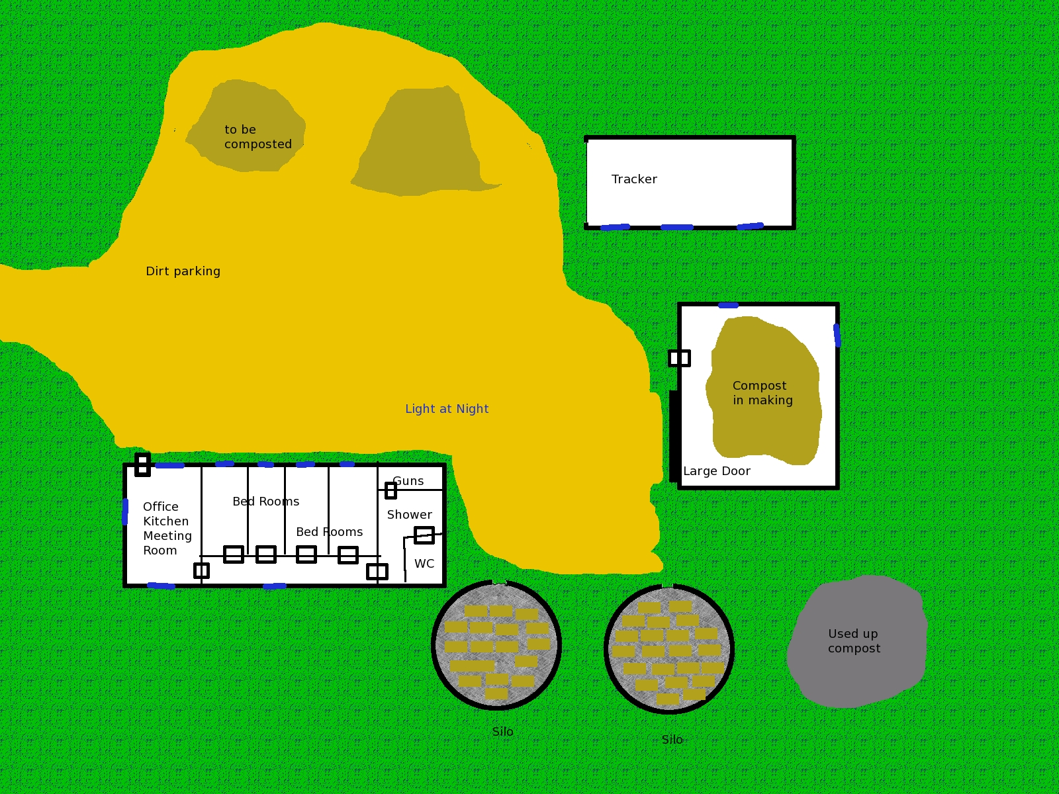

Night view of lighting:

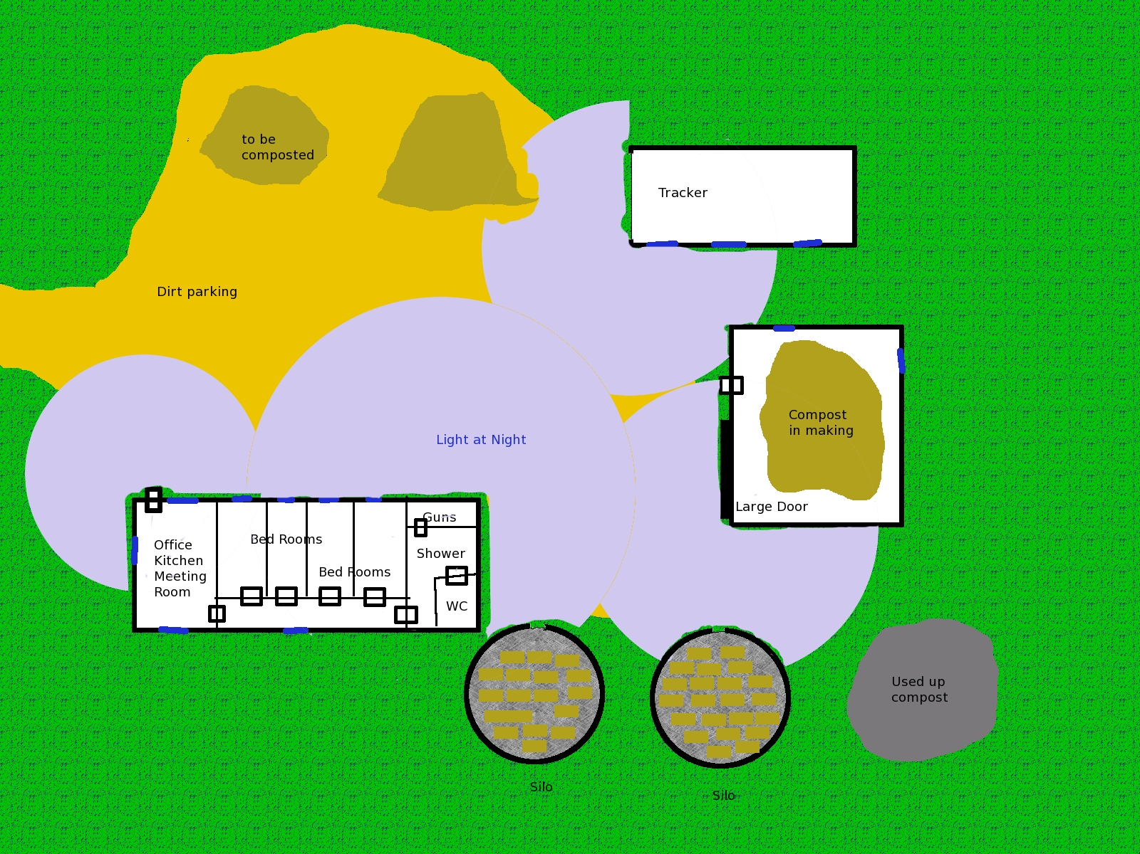

**Mr. Craft (wild card)**

**Attributes:** Agility d6, Smarts d8, Spirit d6, Strength d6, Vigor d6

**Skills:** Channeling d8, Fighting d6, Knowledge (Mystical) d6, Knowledge (Paranormal) d8, Notice d4, Shooting d8, Tradecraft d8

**Charisma:** --; **Pace:** 6; **Parry** 5; **Toughness** 6

**Hindrance:** Obligation (Major)—Enemy agent, Wanted (Major)—Enemy agent by FBI

**Edges:** Arcane Training (Magic), New Power

**Powers:** *bolt I, boost/lower trait, invisibility*

**EXTRA:** Commander of enemy agents

**Languages:**English, German

**Gear & Equipment:**

Mr. Craft has two guns: a revolver and an assault rife. He has one extra magazine for each:

Small revolver; Range 12/24/48; Damage 2d6+1; Rate of Fire 1; Shots 6.

AK47; Range 24/48/96; Damage 2d8+1; Rate of Fire 3; Shots 30, AP2, auto

Mr. Craft carries a knife:

Survival knife; Damage d6+d4 (+1 on Survival rolls)

Mr. Craft wears Kevlar Vest w/inserts; +4/+8 covers torso and give +8 against bullets.

**Tactics:**

Mr. Craft uses three round burst when firing the AK47 to get +2 on attack and damage.

**Enemy Agents**

**Attributes:** Agility d8, Smarts d6, Spirit d6, Strength d6, Vigor d6

**Skills:** Climbing d4, Driving d4, Fighting d6, Healing d4, Intimidation d4, Investigation d4, Notice d4, Persuasion d4, Repair d4, Shooting d6, Stealth d4, Streetwise d4, Tradecraft d8

**Charisma:** --; **Pace:** 6; **Parry** 5; **Toughness** 7/6 (1/2)

**Hindrance:** Obligation (Major)—Enemy agent

**Edges:** Brawny, Quick

**Languages:**English, German, French, Spanish

**Gear & Equipment:**

The enemy agents carry a 9mm pistol, 2 clips of ammo, comlink to other enemy agents and Mr. Craft, the suit (+1/+2), and a survival knife.

9mm pistol; Range 12/24/48; Damage 2d6; Rate of Fire 1; Shots 17, AP1, Semi-Auto.

Survival knife; Damage d6+d4 (+1 on Survival rolls)

**Tactics:**

The enemy target uses double-tap to get +1 to attack and damage.

## Scene 02: The Mushing of Mushrooms

*A large windowless building is found in the middle of fields and fields of crops. It appears someone just installed the plant in place of an old barn. There is one metal door and two loading bays. All are closed. The building is dark in color and there are no windows and anywhere for light to come in. There is a yeast like smell that is quite strong and some steam is flowing out of the plant. The plant seems to be automatic as there is nobody around and no cars.*

The mushroom from the farm are processed into well mush and then the chemicals that make the mushroom so “fun” are extracted by a complex process of filters and other basic chemical extraction processes. The result of the process is extract that is very potent extract. Another computer vampire controls all the machinery and more static zombies do the work.

If the players decide to investigate the vampire will use it static zombies and even manifest itself, not near any sunny open loading dock, and fight the player’s agents. If the players come during the day they will see all the machinery running “automatically” and the mushrooms being mashed and turned into chemicals. If they just observe the vampire will leave them alone. Any agent that knows something about chemicals will observe that there are no control terminals or status screens. Back up storage or tape drives (if in the setting is in the 1960-80s) are also found in the area.

During the night the vampire sends out static zombies, loaded from back-ups, and the zombies drain tanks, due maintenance, fill barrels, and do on. They work until sunrise. Any visits to the plant at night will find it quite busy!

If the agents decide to bring the vampire to an end the Director should just reference the first mission for the monster’s specifications. The vampire can load zombies equal to the number of agents. If the agents attack the back-up systems the zombies do not keep coming back. There are three tape drives or in later settings back-up systems. Each one represents one third of the zombies and any damage from a hit (Director’s discretion) should prevent the machines from loading more zombies.

The barrels are marked to go to the local shipping company to be used as part of a crop dusting product. The agents could just knockout the power or the destruction of the farm makes the plant of limited use. The vampire will wait until night and restore the power.

The process is described below if the Director needs to describe it[24]:

1. Drop mushrooms in tray and water is used to clean the mushrooms. A mix of water and cleaning alcohol sterilize the mushrooms.
2. The mushroom are crushed and chopped into mush in the crushing tank.
3. The filter process removes the biological items of mushrooms that are not needed for extracting the “fun” chemicals. The process is complex and a trade secret stolen by Mr. Love.
4. Hoses are used to move the filtered product to the separation and concentration process.
5. The process is loaded into huge metal columns to draw off the chemicals of a certain weight. This is then spun in centrifuges again to separate the chemicals.
6. The chemicals are then concentrated into a powder.
7. The powder is loaded in barrels.

Contact with the product is safe when it is dry. It has to be ingested or injected to be dangerous. The chemical in low doses makes a person happy and carefree. Over time the victim of low doses person becomes willing to accept commands and do whatever they are asked. They will slowly become uninterested in family, relationships and people and be happy with nothing at all. Finally, the victim will just stop eating and die with a smile.

If an agent consumes any of the power or it is injected into an agent the agent will be very happy and now fearless for a few days.

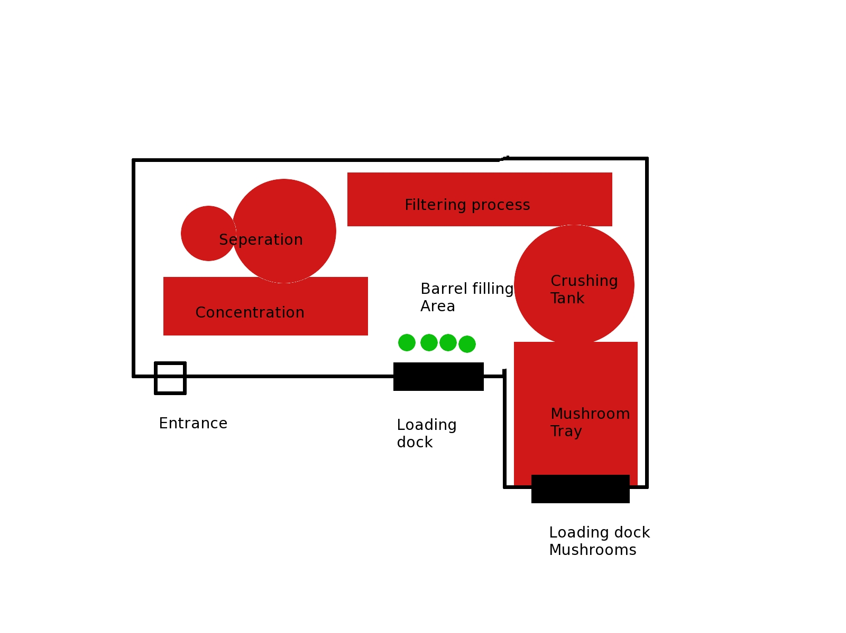

## Scene 03: Strange Day

*“Sam’s Farm Supplies,” and is off a major highway. There are lines and lines of huge and expensive farm equipment. Some look bizarre and could, with just a few paint color changes, feature in a later Peter Jackson movie as exotic orc and goblin siege weapons. Sam sells all sorts of supplies including various large volume farming chemicals.*

*You find a section of insecticide with a sign to use “Add Mr. Love’s love to your insecticide” and it appears that you can save quite a lot of money by using this new “empowering agent.” You see a few familiar barrels.*

The mushroom extract is shipped to a local plant and remixed with concentrated insecticides to be used on various crops. The unwitting folks believe that Mr. Love has come-up with a special biological product that increases the effectiveness of the insecticides without increasing the toxicity of the poisons. It actually works but the special happiness of the mushrooms will be taken into the plants and become part of the food. Thus a lettuce crop sprayed with insecticide to get rid of locust will be made “happy” with the mushroom addition.

The agents need to prevent the shipments and use of the product. The staff at Sam’s is very friendly and quite willing to listen. They seem very happy and quite willing to help in anyway. Mr. Love has added a bit of happiness to the water cooler he supplied with his product. Any one that has some water becomes quite happy and willing to help anyone.

Strangely, Sam’s is making a lot more money than before. The staff is more dedicated than ever and goes that extra extra happy mile. Customers are amazed and will to pay for the extra service and others make up what is lost by one deal with a repeat sale. It seems that friendly and happy and dedicated get you a long way.

The agents should be able to seize the product with the proper paperwork or various skill checks. There are no zombies, vampires, or enemy agents here; just farmers and sales folk.

The agents discover that the product is being shipped out of state and stored in Sam’s warehouse nearby and also sent to an airport.

## Scene 04: The Mushrooms in the Sky

*A tiny local airport on a dirt road is found once again in the middle of farmland. Crop dusting planes are set-up in a row. You can spot barrels of product by the planes. It appears they have already been spraying.*

*A Lizy Bordon is pilot and owner of the new crop spaying company, Wicked Pixie[25]Airlines, that is based at the airport. They have their own hanger. Ms. Bordon is in the terminal drumming up business. The logo is a shadow of a winged pixie sitting on a mushroom wearing the traditional stewardess hat all in purple. Ms. Bordon is wearing a purple suit but with pilot pin and shoulder markings.*

Mr. Love is already testing his new products on crowds. He is using a local crop duster, Lizy Bordon, to spread the happiness[26]. She just got a new load of Mr. Love’s product and is ready to spray some more locusts. The lettuce crop is already been sprayed. She is an enemy agent pilot and any investigating discovers that she is new and attractive. There are also her crew and helpers which are all enemy agents. They are all dressed in cover-alls but all have guns and knives.

Lizy intends to spread “fun” all over the local crops and help the Americans understand that it is just time to relax and let someone else police the world. When she spots the agents she will invite them to her hanger to get rid of the crop dust. Lizy will use her Persuasion and charisma to convince the agents to come with her to the hanger. She also serves iced tea that is treated with just a bit of “fun” to give her another +1 on a Persuasion check. If asked she is allergic to tea. Lizy also has the tarot card, The Fool, and is able to re-roll any skill roll she decides once a round as if spending a Benny. If she rolls a 1 both her wild die and skill die then she disappears in a puff of smoke and the card is left. The image on the card shows some like her as the fool on the card. If the card is taken from her and used then the person using the power rolls a one on both dice and Mrs. Bordon disappears and the card shows her image. The person who drew the card is at risk.

Mrs. Bordon has as many “helpers” as there are player agents. She also get a surprise if she has persuaded the agents to join her in the hanger when she pulls her gun and fires at the closet agent.

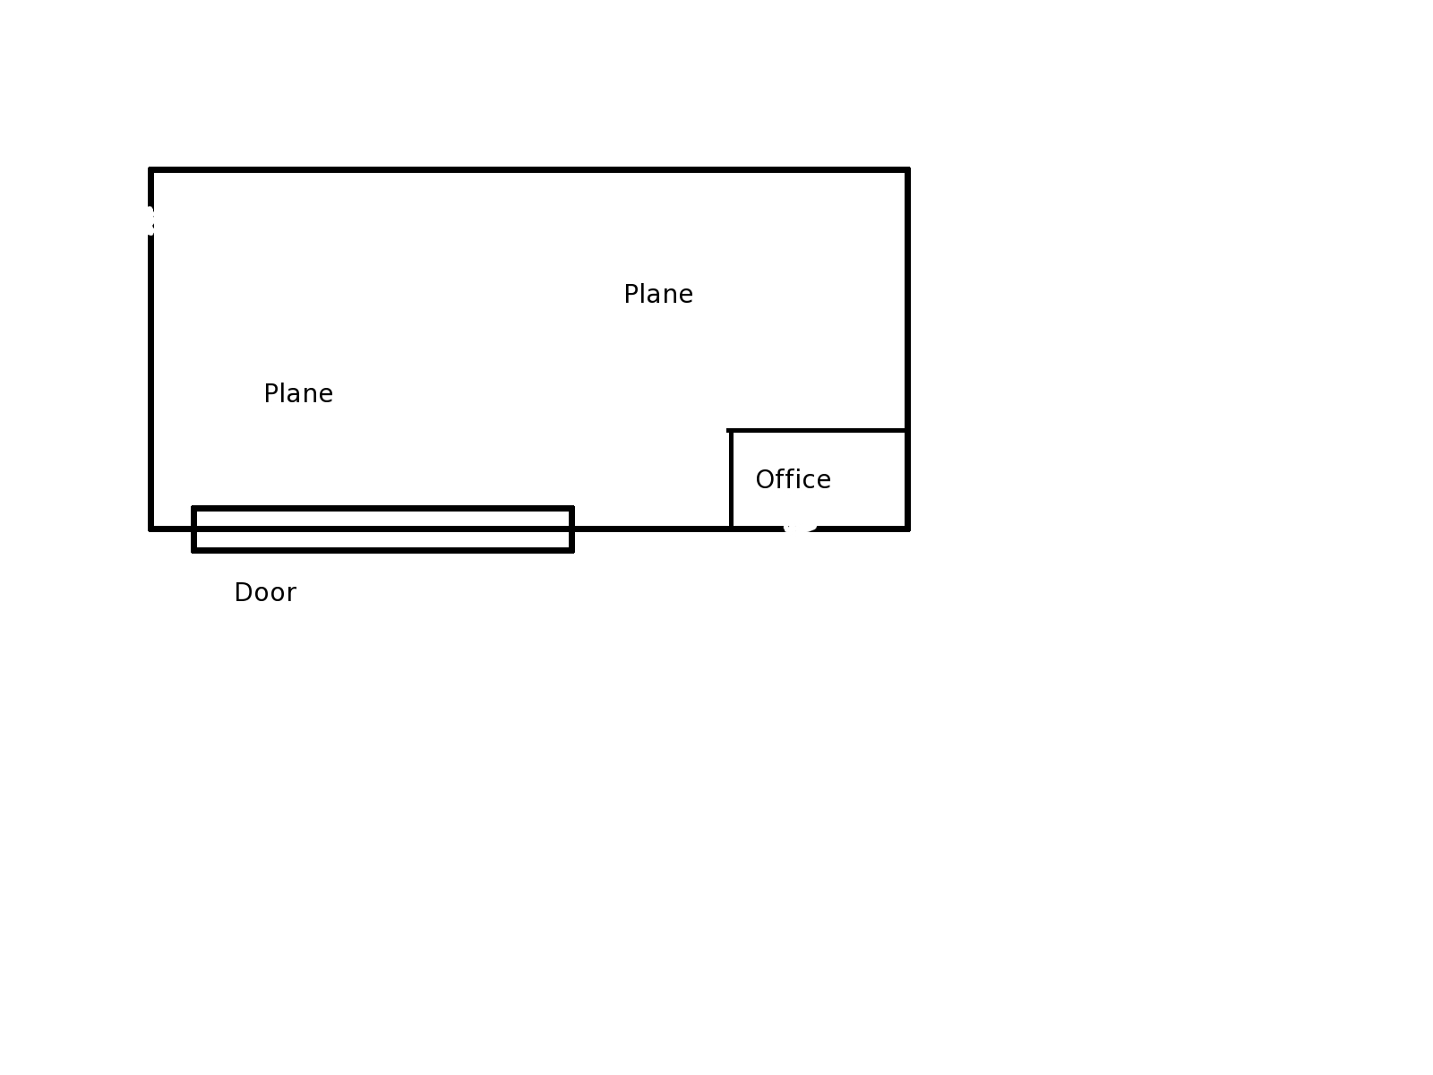

**Lizy Bordon, Enemy Pilot (wild card)**

**Attributes:** Agility d8, Smarts d6, Spirit d6, Strength d6, Vigor d6

**Skills:** Driving d4, Driving (flying plane) d6, Fighting d6, Healing d4, Notice d4, Persuasion d6, Repair d4, Shooting d6, Streetwise d4, Tradecraft d8

**Charisma:** +2; **Pace:** 6; **Parry** 5; **Toughness** 8 / 6 (2/1)

**Hindrance:** Obligation (Major)—Enemy agent

**Edges:** Attractive, Quick

**Languages:**English, German, French, Spanish

**Gear & Equipment:**

Ms. Bordon carries a 9mm pistol, 2 clips of ammo, comlink to other allied enemy agents, and a survival knife.

Worked into her suit is a Kevlar vest +2/+4 bullets; covers torso.

9mm pistol; Range 12/24/48; Damage 2d6; Rate of Fire 1; Shots 17, AP1, Semi-Auto.

Survival knife; Damage d6+d4 (+1 on Survival rolls)

**Tactics:**

Lizy uses double-tap to get +1 to attack and damage with her pistol.

**Enemy Agents Wicked Pixie Airline**

**Attributes:** Agility d8, Smarts d6, Spirit d6, Strength d6, Vigor d6

**Skills:** Climbing d4, Driving d4, Driving (flying plane) d6, Fighting d6, Healing d4, Notice d4, Persuasion d4, Repair d4, Shooting d6, Stealth d4, Streetwise d4, Tradecraft d8

**Charisma:** --; **Pace:** 6; **Parry** 5; **Toughness** 7/6 (1/2)

**Hindrance:** Obligation (Major)—Enemy agent

**Edges:** Brawny, Quick

**Languages:**English, German, French, Spanish

**Gear & Equipment:**

The enemy agents carry a 9mm pistol, 2 clips of ammo, comlink to other enemy agents and Mrs. Bordon, the suit (+1/+2), and a .

9mm pistol; Range 12/24/48; Damage 2d6; Rate of Fire 1; Shots 17, AP1, Semi-Auto.

Survival knife; Damage d6+d4 (+1 on Survival rolls)

**Tactics:**

The enemy target uses double-tap to get +1 to attack and damage.

## Scene 05: Stop a ‘Shroom

*“Smith’s Farm Supplies” shipped much of the Mr. Love’s barrels to a warehouse. It is just collecting here.*

Mr. Love is beginning to ship his product out. The product is being stored at a warehouse while it accumulates to full load and then shipped to places all over the country. The agents may choose multiple ways of dealing with this. They can use a Benny and have an “air strike” cause an “accidental fire” that destroyed it. This is in fact just a “red herring.”

## The Epilogue: The Fool.

The agents were too late and America was impacted by Mr. Love’s plot. The agents were able to stop the plot before it reached a damaging impact.

The Director should find some news items from the time period that suggests something a bit strange with Americans—should not be hard to find. If running in 1974 the Director could include this:

*It is announced that John Lennon and Elton John will appear together. This was decided over a salad lunch.*

*President Ford announced a program to Whip Inflation now, WIN. Nobody seemed to notice.*

*Working productivity reached bottom and appears to be increasing—no explanation is known.*

The director can continue with this not based on history or current events:

*At the agency, “No Lettuce is Available,” sign is posted by an empty salad bar at the agency cafeteria.*

*You notice a large amount of press and commercials on the benefits of avocado in the area. It also appears that some form of ravenous salad loving slug has appears and seems to be destroying the local lettuce crops. It seems that someone has suggested to all of those dreamy lettuce-eating Cascadian that avocado is better.*

Any agent that wishes an interest in farming that has a slot open can select that interest now.

The impact on America will fade. The suggestion is that the strange news items in 1974 are actually caused by the release of a low level psychedelic agent into the lettuce supply.

# Mission: The Moon

The *moon card* is associated to this mission. This card is about dreams and psychic power.

The action moves to Georgian Bay in Canada on a small island. The agency has started to track Mr. Love and to work thought the mass of paper work and payments. The paper work leads to a purchase of an island in Georgian Bay and the building of a “hunting lodge” on the island in the fictional area of Nelson’s Cove. The Director may consider Parry Sound, Ontario, Canada as a good match for this area[27]. The agents are sent to the area to investigate and confront Mr. Love.

The agents are in Canada in late summer or early fall; fishing and boating should be easy at this point in time. Costs are assumed to be 20% more for the tourists. The agents can avoid this 20% as needed by obvious means. The cost of good in Canada is left at the cost as found in the rules for SW.

## The Briefing

The agents receive a short briefing in writing.

*The agency has been contacted by the Canada office regarding Mr. Love’s location. Mr. Love has been associated with operations in a tourist-fishing site in Georgian Bay: Nelson’s Cove. Mr. Love is in possession of an Island in Georgian Bay near Nelson’s Cove.*

*As directed before, Mr. Love has been declared a gamma gamma level threat by the agency and is now treated as an enemy agent. The agents are to eliminate Mr. Love and remove any threat he and his organization have created. As before, agents may eliminate any enemy agents or compromised locals. The agents are given wide discretions, but any actions should be covered by an appropriate cover story. This is a gamma mission with possible omega implications; there must be no press involvement.*

*Knowledge of the threat and its resolution is restricted to agency personnel with no sharing of intelligence with local officials. The agents are to act independent of local officials and possibly in conflict with local laws and processes.*

*The agents are to appear as tourists on a fishing trip.*

*Again in the unlikely event that the tarot deck be discovered (alpha grade occult power), do not approach—contact the Agency.*

## The Mission Profile

The agents are in the open and should act with discretion and should not be in the press or in trouble with the local officials. The agents should be armed and prepared for mystical and paranormal threats. They are to avoid local officials.

Threat: Mr. Love base is a general threat and must be neutralized.

Mission: Investigate Mr. Love’s base and operations. Neutralize same without incidents in press or involvement of local officials.

Parameters: Operation is secret. Press is to be avoided and official records must not include any information on agents or agency.

Supplied equipment: The agents’ travel to Nelson’s Cove is by plane and they pickup their cover in a van at the airport. The van has their equipment they plan to carry and their fishing gear. A small boat and trailer is supplied also. Normal expenses for travel in the area are covered and local currency is supplied: $1000 Canadian each.

In addition agents may receive the following *perks:* cover identity as a tourist on a fishing holiday, gear for same, emergency contact, and two clips of modified rounds (Magic). The modified rounds are considered magical for any creature that is only affected by magical weapons or attacks. There is no additional effect. This has been changed after the agency reviewed the threat and determined magical rounds are better.

Again, all other gear is available excluding air strike.

## Scene 01: Nelson’s Cove

*A nice but obvious tourist-fishing area is found in a nice pleasant fresh-water bay. The town is named after the famous British admiral from Trafalgar. There is a miniature version of Nelson’s Column near the public docks. The town offers over-priced fishing and hunting equipment and dinner can be expensive or cheap as the agents want. The water in the bay is protected and only a storm would make it difficult to cross in an open boat. The area outside of the bay is filled with the 30,000 islands of Georgian Bay and Lake Huron. Many ships have been hauled to the bay, burned to waterline, and left to rot. The freshwater allows the wood to rot slowly so many old hulks still remain in shallows of the bay. This clashes with the floatplanes that take off and land all day in the bay. A larger tourist boat gives tours of the bay and some pretty sites in the chains of islands outside the bay.*

*There are no large cities nearby and the Canada flags remind the agents that they are isolated from the Agency here. Help will not come quickly to this area. The agents will be staying at a local hotel as all the cabin hotels are rented months ahead, The Captain’s, and it has a dock and their small open fishing boat is in the water soon and they are ready for their first day in Nelson’s Cove.*

The author is using Parry Sound as a model for his fictional town of Nelson’s Cove. The Wikipedia entry for Parry Sound can cover a lot of this for the Director if there are specific questions about the town.

This is Canada and a tourist fishing town. Hardware will have ammo and long guns can be purchased at a 20% premium—Military style weapons are not available. Handguns, other than target pistols[28], will be basic protection; expensive and better quality handguns will be unavailable. Fishing guides are available as are maps and various obvious equipment options for fishing, hunting, bird watching, and so on. The water is a not warm, reaching the 70Fs only in late July and early August, and few come for the swimming but the wrecks in the bay are easy to reach with a snorkel. Agents can swim in the water for hours without risk of hypothermia. Georgian Bay is colder than fictional Nelson’s Cove’s bay waters, but again the sun has warmed the surface so it is not dangerous in the summer or early fall. Diving deep into the lake, deeper than thirty feet, is how to experience real cold fresh water at any time of the year and a wetsuit would be required.

The agents can get a map of the area and must follow regulations to the unusual exactness that Canada requires of fishermen. Licenses are expensive for outsiders and catches are checked. Violation of fishing regulations means loss of license and large fines. Violations of safety regulations in boats means arrest, jailing, and fines. Agents will likely get to experience some of this, but it will not “blow” their cover. Many outsiders may contributions to the locals via fines.

Specifications for Canadians at Nelson’s Cove are below.

### Persons and Points of Interest

The agents may need

**The Captain:** *The pink paint is fresh, the pool is clean, and rooms are available. The rooms are plain and just a bed, wall heater, and bathroom. The rooms are also cost twice what you would expect. There is a dock behind the hotel that is available to the guests on a small channel that connects to the bay. There is no hotel restaurant and no ice.*

*The owner is also the clerk, “Captain” Clarke Smith. A graying and no-nonsense Canadian with a slight French accent dressed in a blue captain uniform without any military badges. He expects more information that most hotels, “Canada holds us to a high standard of information for our guests’ safety,” he explains as he takes copies of passports, credit cards, and fishing licenses. You watch him create a folder for each guest and files them in a locked cabinet. He has the key on his belt. More security than you would expect. Keys are then distributed. “Captain” Clarke also supplies laminated sailing charts, “To be returned to the me when you leave,” he says with a smile that suggests he will charge a lot to the rooms of the agents if the charts are not returned. “Enjoy your fishing!” he states after cover the basics of the area with the agents.*

This is a local hotel with clean but simple rooms and an outdoor unheated pool—not that often used. It is a bit expensive as it is the only hotel with rooms in the town, as the hotel does not take reservations in advance. The locals are happy with the owner’s policy; there is always a place for those tourists that have more money than time to plan. Locals get 20% off the room rate—that is not advertised.

The services available are wake-up calls, local calls are free, long distance is very expensive—five dollars Canadian a minute, currency exchange is available at a reasonable rate, and rooms are cleaned everyday by Emily House, a local girl who cleans during the summer to cover the cost of college.

**“Captain” Clarke Smith:** The owner of The Captain, “Captain” Clarke Smith, was recently “bought-out” by Mr. Love and is now a paid employee. This is not widely known and the “Captain” pretends to still own the place. Mr. Love needs a place for his agents to stay and also he needs someone to watch for outsiders. “Captain” Clarke Smith records all names, addresses, copies documents, and creates a folder on each visitor. He sends a summary of the guests to Mr. Love with the agents headed to his island every couple of days.

“Captain” Clarke will not interfere with the agents. He just reports visitors to Mr. Love and also any incidents or strange behavior to Mr. Love. The agents may consider him a compromised local, but he is not much of a threat. He has a master key that opens all the rooms. There is also a small cash box that is locked with a key. He makes a deposit every work day so the box contains only a few hundred in US and Canadian currency.

The agents succeed at a Investigation check will learn that The Captain was recently sold to Mr. Love and that “Captain” Clarke Smith will be retire after the season ends. A Streetwise check will learn that “Captain” Smith is retiring soon and has purchased a new truck and spent much on his house. He was always broke before.

The “Captain” if involved in combat is good with a gun and a knife. His specifications can match those below for Canadians.

**Emily House:** Emily House is a local who works at the hotel cleaning and fixing anything. She has lived here all her life, but goes to college in the USA at Columbia. It is very expensive and even with her scholarships she still need money. Emily is pretty in a tomboy way and often wears shorts and a t-shirt that fits a bit too tight. Emily gets lots ogles when she works and just decided to look the part. She is not interested in tourists and has a bad opinion and is unfriendly to them for skill checks. Emily needs money and asking her a question and paying her a tip for the information will have a positive reaction. Emily has the other master key, but she likes her job and the money and so will not likely open a room for the agents if asked. Even a large bribe will not work. Emily is an honest gal and if approach with money for information she is will to give it. If shown credentials will have Emily follow instructions, but she will tell “Captain” Clarke Smith about the credentials and any activities even if told to keep it secret. She believes that the “Captain” should know everything going about his place.

Emily House is aware that there are some odd folks staying at the hotel. The guys all pretend to be hunters and shooters. They have a boat and head out to their pistol range. Their rather thin cover story is that they are practicing for an international pistol contest. Emily has mentioned them to the “Captain” and he has told her to ignore them.

If Emily is involved in combat for whatever reason, she is good with a gun and a knife. Her specifications can be made up on-the-fly from the example below.

**Enemy Agents:** Misha Jones, Tyler Nelson, and Rusty Tailor are enemy agents that are pretending to be tourists and use a rather thin cover that they are here to practice target shooting at Mr. Love’s range on his island. Each enemy agent has a silver chain with a simple silver key on the chain around his or her neck. This key allows them to enter the magic that protects Mr. Love’s island (see below). The only means that the player’s agents have to meet up with Mr. Love is to get possession of one of the keys or to be taken captive and taken to the island.

The enemy agents get supplies, mail, and news for Mr. Love and then carry the items to the island. Generally the enemy agents are bored and do what they are told. They do nothing to draw attention to themselves and use a hot plate to cook their meals. Emily was surprised that the “Captain” allowed that, but she has been told to ignore them and just clean when they ask. They often clean their own room, it is something to do, and sometimes actually go fishing and cook what they catch. A Notice check will detect that the “fishing vests” are made of Kevlar.

**Fishing and Local Guide, Bob Bell:** *Bob Bell is the local guide that is recommended to the agents. Bob is a middle-aged American who moved to the area years ago after marrying a Canadian. His wife passed way some years ago and so he fills his days with fishing, giving tours, finding fishing for others as a guide, and local salesman at the hardware for appliances, carpet, and furniture. The hardware sells everything here in Nelson’s Cove. Bob knows the area very well and is well aware of Mr. Love’s island and that the folks at The Captain hotel travel there nearly every day.*

Bob wears a vest that is much like the enemy agents vest. If asked about it he will smile and say he found it on a beach and it was so nice he decided to dry it out and wear it. “It can’t be cut by a knife,” he will tell the agents with raised eyebrows. Bob is unaware that he is wearing a Kevlar vest that once worn by an enemy agent. The enemy agent failed to bring his silver key to the island and was killed. Mr. Love had the body of the forgetful enemy agent weighted-down with a cement brick and thrown in the deep of Lake Huron. The lake actions freed the vest and washed it of any remains.

Bob can take the agents anywhere they like to go by boat and also can fly a floatplane that he owns 50% in called the “Blue Streak.”

Bob has been near Mr. Love’s island and has flown over it. It was always a strange island, known as Strange Island, and its name in the native people is translated as “land not land” which can also mean strange. See below for more scenes on that information.

Bob specifications are up to the Director and may use the Canadian specifications below. Bob lives in a small cabin next to the hotel and the water. It is also cleaned by Emily and is very neat and orderly. Inside are only books on fishing and spy novels. Business records show that Bob makes a good living in the summer and has saved a large amount of money. He has no involvement with Mr. Love and avoids him.

**The Native People:** The local native people hate tourists and what they have made the area into. They are prone to small acts of violence, sinking a boat at a dock late at night, or stealing equipment when provoked. The local police will have a talk with them if this gets out of hand and then all actions will stop. Mr. Love has made a substantial bribe to the local native people leaders and so is under their protection. They have been specially asked by Mr. Love to ignore any outsiders and tourists. Any attempts to connect with the native folks in this mission will fail. They are willing to ignore the player’s agents and to follow any wishes of Mr. Love that is not too far outside of legal.

**Enemy Agents at Nelson’s Cove**

The Director can use this as the model for the enemy agents. The agents are not always armed with a pistol as this is Canada and carrying hidden weapons is forbidden for tourists.

**Attributes:** Agility d8, Smarts d6, Spirit d6, Strength d6, Vigor d6

**Skills:** Climbing d4, Driving d4, Driving (Boat) d4, Fighting d6, Healing d4, Intimidation d4, Notice d4, Persuasion d4, Repair d4, Shooting d6, Stealth d4, Streetwise d4, Tradecraft d8

**Charisma:** --; **Pace:** 6; **Parry** 5; **Toughness** 8/7 (4/2) 4AP

**Hindrance:** Obligation (Major)—Enemy agent

**Edges:** Brawny, Quick

**Languages:**English, German, French, and Spanish

**Gear & Equipment:**

The enemy agents carry a target pistol, 2 clips of ammo, a Kevlar vest disguised as a fisherman’s utility vest, comlink to other enemy agents and a survival knife.

Target pistol: Smith and Wesson .22 Long Range, AP 1, Range: 15/30/60, Damage: 2d6-1, ROF: 1, Shots: 10.

Survival knife; Damage d6+d4 (+1 on Survival rolls)

**Tactics:**

They are pretending to be tourists taking special training on target pistols for an international contest later in the year. They will avoid gunplay and use the knife to avoid upsetting the locals and making a lot of noise. They will also try to take any enemies alive and take them with them to the island.

**Canadian at Nelson’s Cove**

These are some general numbers for the Director to use as needed.

**Attributes:** Agility d6, Smarts d4-d6, Spirit d6, Strength d4, Vigor d6

**Skills:** Climbing d4, Driving d4, Driving (Boat) d6, Fighting d6, Healing d4, Knowledge (Nature) d4-d6, Knowledge (Local) d4-d6, Knowledge (Winter sports) d4-d6, Repair d4, Shooting d6

**Charisma:** --; **Pace:** 6; **Parry** 5; **Toughness** 5

**Hindrance:** Obligation (Major)—Loves Canada

**Edges:** Brawny, Quick

**Languages:**English, and some French.

**Gear & Equipment:**

Smaller survival knife; Damage d4 (+1 on Survival rolls)

## Scene 02: Fishing

*The agents are using Bob’s boat for fishing, nicknamed the “Batmobile” as it is black and has lots of lights and gadgets. Bob seems to like to know where he is at all times and where the fish are. Fish finders, depth finders, and even radar allow Bob to be safe and happy. You notice that Bob is nervous driver and always checking his location, “There are rocks everywhere and strange currents come and go all the time.”*

*He parks the boat near Strange Island. Bob gets much more relaxed as he anchors, two anchors, and passes out fishing poles. The island has a small dock and is about a quarter mile across and square in shape and each “corner” pointed at one direction. “It actually points at true north and aligns with the North Star,” Bob says. Mist or steam from the water that hits the dock area on the island makes it hard to get a clear view of the island. “There is rumors that there is a mansion on the island,” records do not show any permits were ever granted and the tax records show no improvements other than a privy, camp sites, and dock,” Bob says as you look at the island. He smiles, “there was a question about taxes and the rumored mansion” that I had to clear-up once for them. Strange Island is bare.*

*“A fishing trick that works just here near Strange Island,” Bob says as the fishing get boring. “Never pull the fish in straight as the current or a larger fish, we have large Muskie in these waters, will take the fish and you will be lucky to get your hook back,” Bob says with a smile. “There is nice Bass and Walleyes near the island,” Bob says thinking back to previous visits. “We don’t usually have them in the open water as they are taken by the Muskie,” Bob tells you. Looking thoughtful, “I have never caught a Muskie by this island,” he says. “But I have lost a lot of fish here when I pull them in straight,” he tells to nobody particular.*

The fishing is good. The agents find that Bob is correct that when fish are pulled in in a straight line that the fish is lost and the line is often cut. When pulling back and forth and moving around the boat to drag the fish in no straight paths it can be netted, Bob will not touch the water but instead uses a net to capture the hooked fish, gets the fish onboard and then removes the hook with pliers. Smaller fish are returned with Bob very nervously lean over and placing the fish kindly in the water with a towel. He avoids hurting the returned fish as much as possible. He places good fish in a live tank. If the player’s agents go fishing somewhere else with Bob they find Bob quite willing to touch the water and is much less nervous.

Bob will not tie up to Strange Island and will only show the island to the agents and fish there.

If the agents wish to stay out for some time to watch the island the will see the enemy agents come in a rented metal boat, tie up to the dock, then some mist will obscure them as they near the end of the dock and disappear. If the ask Bob about that, he will suggest the disappearance was them just entering the trees. “There is a twisty path just passed the dock that is hard to see from here that goes to the campsite and the shooting range,” Bob will explain.

## Scene 03: Flying

*Bob Bell’s floatplane, the Blue Streak, sits three and himself. He makes jokes and then checks that the passengers have not recently eaten and ensures they have used the water closet before they take off. “This is the Blue Streak not the Brown Streak,” he explains to the passengers.*

*Bob flies over the islands and goes over a well-practiced patter of local legends, stories, and natural information. Bob takes questions and has the answers ready as he has made this trip often.*

*He flies over Strange Island and has the passengers watch as the shadows play on the trees and mist rises. “Look!” he calls out. For a moment a shadow of a large mansion is seen, but it disappears into a mix of shadows of trees and rock on the island, “Yes, we even tried to tax Mr. Love who owns the island for that mansion, but it is just a trick of light and mist,” there is no mansion when we looked over the island some years ago with the tax-man.*

A player’s agent with mystical or paranormal knowledge can make an attempt to understand what they saw. There is an alternative dimension that covers just the island and in the dimension there is a mansion on the island. On a raise the agent also understand that there is a token that allows access to the dimension.

A player’s agent that makes a raise on a Notice check will also see something dark moving near the “mansion.” The island contains some dark guardian or guardians.

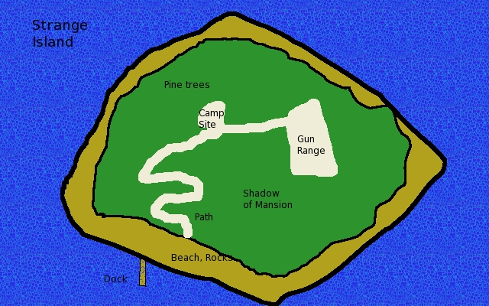

## Scene 04: Island without Key

*As the boat approaches the dock of Mr. Love’s island there is a sudden amount of mist that obscures the island for a minute, but it fades and the dock and the island reappear as they were before. The island is strangely quiet and seems a bit well scary to you. The “beach” is mostly rocks and the pine trees seem to be growing on the rocks finding some soil here and there.*

*A twisting path, passing around the rocks, has been made and flattened to make walking easy. It leads to a clearing with an aging picnic table and privy and a clear-cut that forms a gun range. A natural sandy hill makes a safe backstop for the gun range. Tattered targets are placed on logs that show many bullet hits.*

The agents have explored the island without a silver key from the enemy agents. They will find the island not very interesting: There is a path to a camping site with a privy and then to a gun range. A gun range is also not very interesting. It is a clear-cut of trees backed by a large sand formation that apparently absorbs the gunfire. Tattered targets are placed on badly shot-up logs placed in the ground before the sand. A Notice check will point out that the targets are quite old and that the gun range seems to be disused.

A search of the campsite shows no recent signs of use. The privy is full of spiders and shows little signs of use. The sears catalog found inside is ruined by rain.

Unless the players have their agents move in curves and go half speed, the Hunting Darkness (see Scene 99 for monsters) on the island will detect the agents and teleport next to them and attack. Any agent that has training in paranormal or mystical knowledge may remember a legend about creatures that attack from angles and straight lines. They will know to move half pace to prevent the Straight Line Attacks from the Hunting Darkness.

The agents will face a Hunting Darkness each. The agents can reach their boat and leave the Hunting Darkness on the island. More will come each five minutes later. The agents should leave the island!

## Scene 05: Arrest

*A nice but serious Royal Canadian Mounted Police member in his red uniform has stopped one of the agents. He identifies himself as Jeffery Herring of the RCMP and asks the agents who is the captain of their boat, he points at it. The captain is then arrested for having an open container of alcohol, Pabst Blue Ribbon, in the boat by officer Herring. Officer Herring also checks their catch and finds all of the rules have been followed. No serious error in following the fishing regulations.*

The native people have thrown some empty beer cans in the agent’s boat and then made an anonymous call to the local police about the agents drinking and driving. They were angry that one of the tourists has over-fished his limit. The put the beer cans in the wrong boat.

A Notice check will notice that Officer Herring seems to be unhappy with the “bust.” He would like to catch real criminals or at least a violation of fishing regulations. A Streetwise check discovers that the native people often set-up folks who have been over fishing to be searched by the RCMP. Another group of fisherman who left yesterday may have been over their limit.

Officer Herring knows this to be set-up. He will have to arrest the captain of the boat, take him/her and book him/her, fine him/her $300, and then will fill-out the paperwork that he will make a mistake on the date—previous year will be “mistakenly” be entered as date of crime. The charges will be dropped the next day and the $300 refunded as the paperwork was wrong.

This is a “red herring” and forces the players to be split-up and face the local officials while keeping to their mission[29]. The agents should just get booked and pay the fine for having an open container in the boat. The agents should not get into a fight with the locals.

## Scene 06: Silver Key and Island

*As the boat approaches the dock of Mr. Love’s island there is a sudden amount of mist that obscures the island for a minute, but it fades and the dock and the island reappear but now it is covered with a huge mansion. The trees are gone and all is a huge hideous mansion of multiple windows. It glows with blue light as if in moonlight. It is now dark and night and the stars are none you have seen before. “I don’t think we are in Canada anymore, Toto” someone says as the boat pulls up to a dock now made of cut stones.*

*As the boat pulls up a man in a white on white suit with silver hair steps out of the house. “My house has many rooms, but none are for you!” he screams in a voice that drips with anger. The face you have only seen in a sketch, Mr. Love.*

The agents have entered Mr. Love’s dimension he built with the moon card. As the agents land on the island Mr. Love moves to meet them in an open area and summons one Hunting Horror for each agent. It is twilight but not dark. Mr. Love and the hounds may teleport in this area. The house is made up of every room that Mr. Love has teleported into. A copy of each room appears here in the mansion. He cannot teleport out of the dimension but can teleport from a boat once off the island and his dimension.

There are White House rooms, hotel rooms, and other important offices and even bank vaults are in the mansion. A Notice check will spot that the house is made up of rooms duplicated from the real world and that some are from important political locations.

Mr. Love is carrying the moon card from the tarot deck. If removed from him he will awaken, even if badly hurt, and then run and be attacked by a group of Hunting Darkness that appear and he is torn to bits. The mansion will begin to collapse on itself once the card id taken. It will vanish as will much of the island in the real world. The agents will have just enough time to get in their boat and get clear. The will see the mansion fade as does the twilight and then a vortex will build and parts of the island in the real world will collapse. Finally, the waters will spill in and drown the island. This is the end of Mr. Love and the tarot deck still in the house when it was destroyed.

**Mr. Love (wild card)**

**Attributes:** Agility d6, Smarts d8, Spirit d6, Strength d6, Vigor d6

**Skills:** Channeling d8, Fighting d6, Knowledge (Mystical) d6, Knowledge (Paranormal) d8, Knowledge (Occult) d8, Notice d4, Shooting d6

**Charisma:** --; **Pace:** 6; **Parry** 5; **Toughness** 14 / 10 8AP

**Hindrance:** Delusional (Major)—believes he should control the world, Wanted (Major)—Enemy Agent

**Edges:** Arcane Training (Magic), New Power

**Powers:** *bolt I, invisibility*

**EXTRA:** May summon Hunting Darkness equal to the number of the player’s agents as a free action once in combat and he may teleport in any enclosed space that has angles as his standard move action.

**Languages:**English, French

Mr. Love has a small revolver he may use, he has no easy reloads: Range 12/24/48; Damage 2d6+1; Rate of Fire 1; Shots 6.

## Scene 99: Monsters

The list of monsters and curses for this mission follows.

**Hunting Darkness**[30]

The Hunting Darkness is a spirit made of pure darkness. When seen in light the shape of the darkness hints at a huge wolf. The creature maybe made of darkness and shadows but it will not pass through walls and cannot fly. It “runs” on the ground. A Hunting Darkness can teleport to any room that has strong angles in it. Any creature that moves in a straight line can also be attacked by the Hunting Darkness as it can then teleport behind the creature as a free action and attack.

The Hunting Darkness attack is much like a bite of a wolf except all the teeth marks are needle-like, sort of a wolf with snake fangs lined in rows. The horror of the attack is that no real creature can make a bite like this without its own fangs cutting into its own jaw.

The creatures are a lesser version of the Hounds of Tindalos mentioned in many Cthulhu mythos[31].

Large bodies of water stop Hunting Darkness as water has no “angles.” They can teleport into the water to attack creatures swimming in straight lines and then teleport back to land. Any creature near them may move at half the creature’s pace to keep their movements from creating a straight line. This is walking in curves.

**Attributes:** Agility d8, Smarts d4, (A) Spirit d4, Strength d8, Vigor d8

**Skills:** Fighting d8, Intimidate d8, Notice d6

**Pace:** 7; **Parry** 6; **Toughness** 8

**Special Abilities**

* **Bite:** Str +d6
* **Teleportation:** The Hunting Darkness can teleport into or about in any enclosed space with angled walls, corners, or decorations as its standard movement.
* **Straight Line Attacks:** Any creature that is in sight of a Hunting Darkness that moves move than half it movement provoke a free action teleportation next to the creature and the Hunting Darkness may make an attack on the creature as a free action.
* **Immune to Environment:** The Hunting Darkness is immune to any environmental effects such as drowning, vacuum of space, and so on.
* **Fleet-Foot:** Hunting Darkness roll d10s instead of d6s when running.

## The Epilogue: The Moon.

*A small note about a collapse of a salt-dome under an island in Georgian Bay is noticed in paper. “Island Missing: Apparently a salt-dome collapsed in Georgian Bay under an island.*

*The Agency has been informed that many unexplained security breaks and loss of intelligence has stopped. It seems that all the government agencies believed that their secrets were not safe or stolen. The world was on the edge of war and now the world is a bit safer now.*

# Epilogue

The agents defeated Mr. Love and his evil plans of world domination. His ability to dose folks with happy mushrooms and to access almost any place on earth is ended.

# About the Author

Michael R Wild is the author of many unpublished adventures. He enjoys writing his own adventures for his players. Michael played AD&D in the 1980s but stopped playing after college and did not play again until 3.0 was published. He rewrote some of his AD&D adventures for 3.0 and 3.5 and began to write a lot of 40+ page adventurers from scratch. Michael enjoys writing adventurers for 4E. This is his first attempt at an adventure written for *Savage Worlds* and *Agents of Oblivion*.

Michael resides in Aloha, Oregon since 1996 with his wife Susan and works at a local shoe company as a computer guy.

All pictures and drawings are from the author—there is nobody else to blame. He is improving his skills.

1. *Savage Worlds* is a great gaming product from Pinnacle Entertainment Group and they have not approved this writing nor does the author intend in anyway to conflicts with their rights and copyright. He just wants to play the game with more material that he wrote.
2. *Agents of Oblivion* is also a great gaming product from Reality Blurs, LLC. and this writing is also not approved by them nor does the author of this document intend in anyway to conflict with their rights or copyright. The author’s intent is to write more material to play the game in his campaign.
3. The author did work for a small local company that developed software for hospital supplies inventory in the mid-80’s on IBM mini-computers.
4. With respect to Catch 22 character Major Major.
5. Based on vampires found in SW.
6. Based on zombie found in SW.
7. From The Princess Bride by William Goldman, 1973. The setting for the original campaign is a version of 1974 and so the book would have been out for about a year.
8. AoO page 19.
9. Advanced Mineralogy: Volume 3: Mineral Matter in Space, Mantle, Ocean Floor, Biosphere, Environmental Management, and Jewelry, edited by Arnold S. Marfunin, ISBN-10: 3540582452, 1998, Germany, Springer Press.
10. If the setting is after 1977 then the books include Alaska mushroom books by Ben Guild.
11. See “Surprise” SW.
12. Based on zombie found in SW.
13. These are kinder and gentler rules than the poison rules fond in SW. The Director could use standard paralysis poison rules instead.
14. See Stealth (Agility) rules in SW.
15. Based on earth element in SW.
16. Chariots of the Gods, by Erich von Daniken, 1968.
17. The author’s late father-in-law, Ben Guild, was a mycologist and wrote The Alaska Psychoactive Mushroom Handbook in 1979.
18. The author admits that his family years ago might be involved in an incident in Canonsburg, Michigan that gave him this idea.
19. The Director may use the more complex rules found in another setting for Savage Worlds.
20. A drawing of H.P. Lovecraft would work but it is not H.P. Lovecraft—he just looks like him.
21. The skeletons are seen in the 1974 movie “The Golden Voyage of Sinbad.”
22. Based on skeleton found in SW.
23. Based on ghost in SW.
24. The author has no idea how to do this. The process is made-up and based on actually how cheese is made and how to enrich uranium as described in the press for the Iran nuclear program.
25. Also a hair dresser here in Beaverton, Oregon.
26. The author avoided the obvious use from Ian Fleming.
27. Please see <http://en.wikipedia.org/wiki/Parry_Sound,_Ontario> .
28. Smith and Wesson .22 Long Range, AP 1, Range: 15/30/60, Damage: 2d6-1, ROF: 1, Price: 900, Weight: 2, Shots: 10. The cost of the gun will be 1080 to include the tourist extra 20%.
29. The author’s father had an experience much like this.
30. Based on dire wolves in SW with just a few adjustments for H.P Lovecraft stories.
31. See <http://en.wikipedia.org/wiki/Hounds_of_Tindalos> .